Math 1030 #10a
Loans, Credit Cards and Mortgages
Loans
Loans, credit cards and mortgages are ways you borrow money. When you borrow money, the bank is basically making a lump sum investment and getting a periodic return.

Principal is the amount of money owed at any particular time.
Interest is charged on the principal.
To pay off a loan, you should pay the interest and also some part of the principal.

An installment loan (amortized loan) is a loan payed off with equal regular payments.

Loan Payment Formula (Installment loans)
$$PMT=\frac{P⋅\left(\frac{APR}{n}\right)}{\left[1-{\left(1+\frac{APR}{n}\right)}^{(-nY)}\right]}$$
$$\begin{matrix}PMT & \text{= regular payment amount} \\ P & \text{= starting principal} \\ APR & \text{= annual percentage rate} \\ n & \text{= number of payments per year} \\ Y & \text{= the term of the loan (years)} \end{matrix}$$

EX 1:
You have a student loan of $\$40,000$ with an APR of $6\%$. Compare monthly payment amounts and total amount paid for these options.
$$PMT=\frac{P⋅\left(\frac{APR}{n}\right)}{\left[1-{\left(1+\frac{APR}{n}\right)}^{(-nY)}\right]}$$
15 years | 25 years

EX 2:
For the loan in example 1, make a table showing the amounts of each monthly payment that goes to the principal and to the interest for the first three months. ( $\$40,000$ at $6\%$ for 15 yrs )
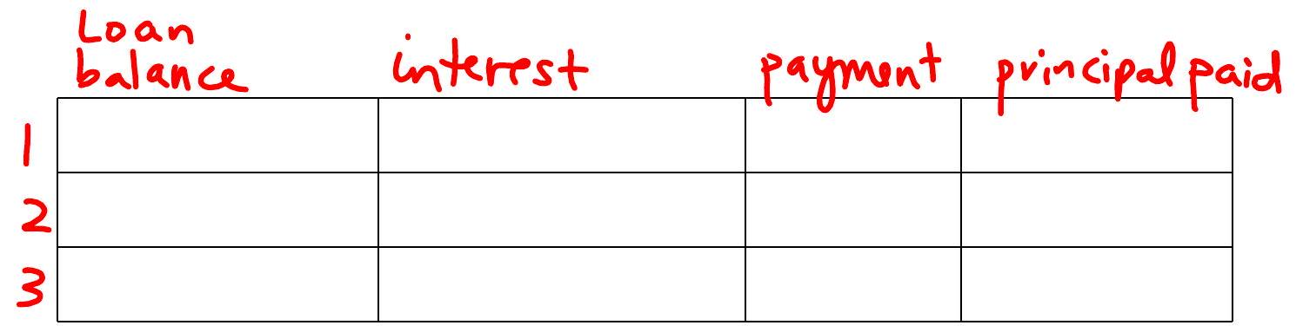

EX 3:
You borrow $\$4000$ to buy a used car. You can afford monthly payments of $\$150$. Which of these meets your needs?
$$PMT=\frac{P⋅\left(\frac{APB}{n}\right)}{\left[1-{\left(1+\frac{APR}{n}\right)}^{(-nY)}\right]}$$
2 years at $8\%$ APR

3 years at 9% APR

4 years at 10% APR

EX 4:
A payday loan company charges $\$150$ to borrow $\$1000$ for 2 weeks. What is the APR?

