Math 1030 #13b
Functions: Building Blocks of
Mathematical Modeling
Domain and Range

Representing Functions
- Numerically – in a table
- Graph – picture (is worth 1000 words)
- Equation

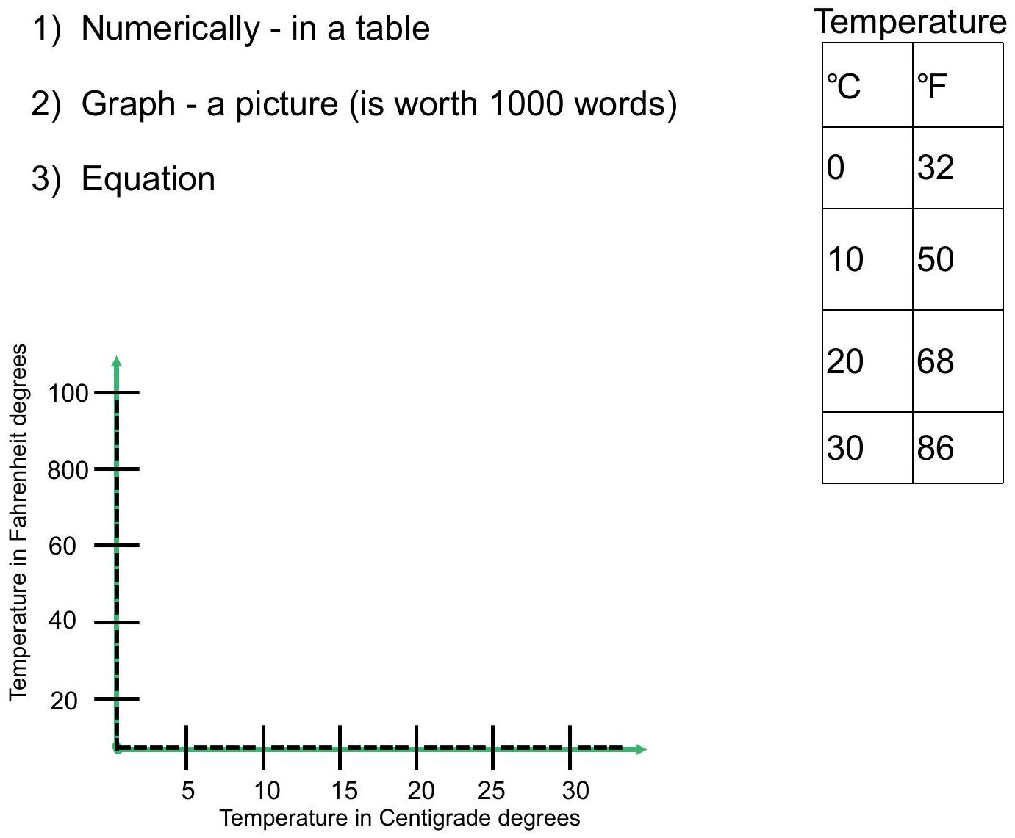

Domain - the set of values that both make sense and are of interest for the independent variable.
Range - the values of the dependent variable that correspond to the values in the domain.

EX 1:
Consider this graph.
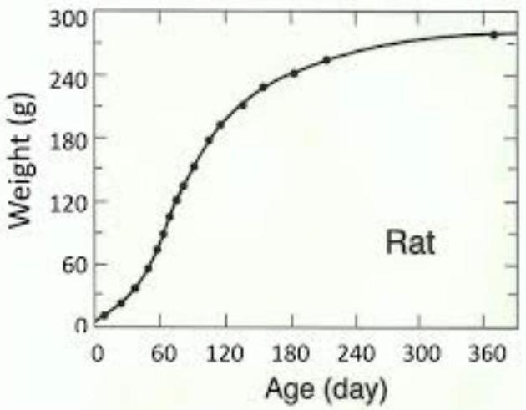

- Identify the independent and dependent variables and describe the domain and range.
- Describe the function in words.

EX 2:
Consider this table.
Altitude (ft) | Boiling point  of Water ( $^{∘}F$ )
0 | 212.0
2,000 | 208.4
4,000 | 204.8
6,000 | 201.0
8,000 | 195.5

- Identify the independent and dependent variables and describe the domain and range.
- Make a clear graph of the function.
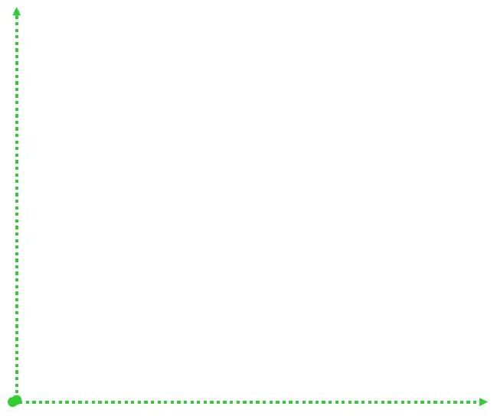
- Describe the function in words.

