Math 1030 #14a
Linear Modeling

A Linear Function has
- a constant rate of change
- a straight-line graph
The Slope of the line is the rate of change.
The greater the rate of change, the steeper the slope.
rate of change $=$ slope $=\frac{ \text{change}\text{ in dependent variable} }{ \text{change in independent variable} }=\frac{ \text{rise} }{ \text{run} }=\frac{y_{2}-y_{1}}{x_{2}-x_{1}}$

EX 1:
Discuss the slope (rate of change) in each of these graphic examples.
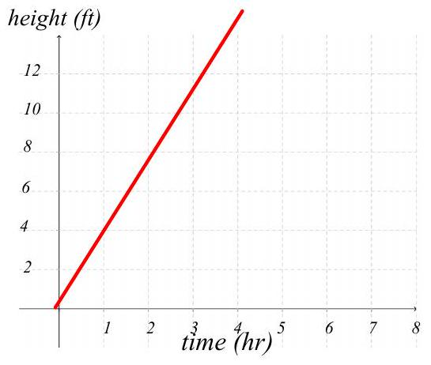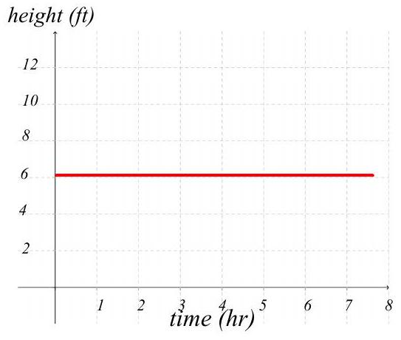
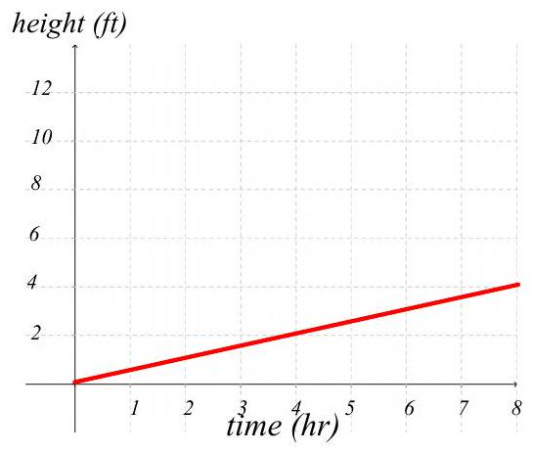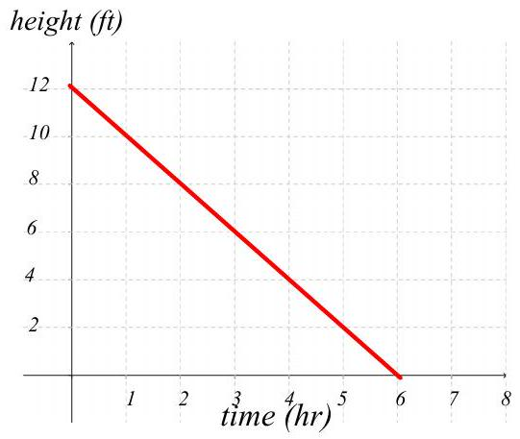
A Price-Demand Function is a good example of slope.

EX 2:
Write a statement that describes how one variable varies with respect to the other. Then answer the questions.
A gas station owner finds for each 2 -cent increase in the price of gasoline, she sells 120 fewer gallons of gas per week.

- How much more or less will she sell if she raises the price by 10¢ per gallon?
- What if she decreases the price by 5¢ per gallon?
- What is the slope (rate of change) in this problem.

