Math 1030 #14c
Linear Modeling
Applications

EX 1:
When your first child is born, you purchase a tree to plant. This graph shows the diameter of the tree as a function of time after you planted it.
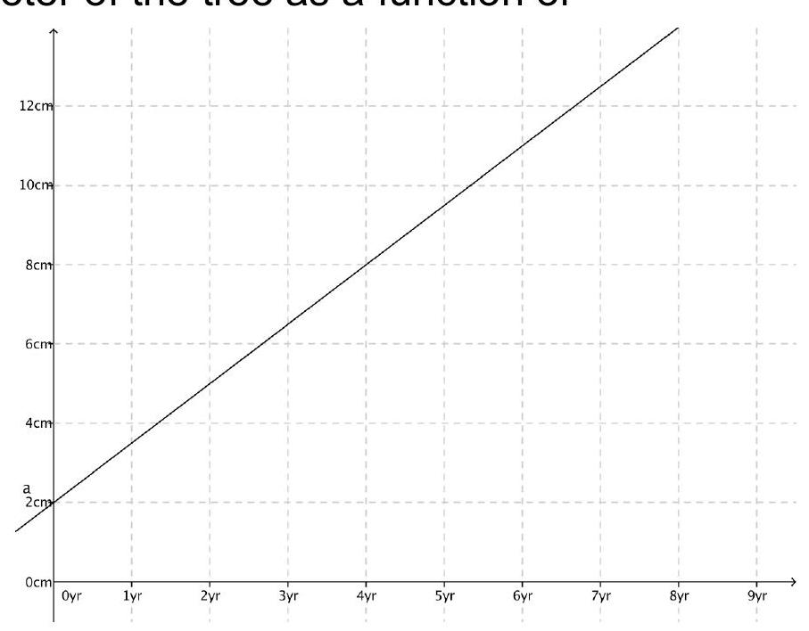

- How much does the diameter increase each year?
- When is the diameter 10 cm?
- What was the diameter when you planted the tree?
- When the child is six, what is the diameter of the tree?
- Write an equation of this relationship.

EX 2:
Your prize-winning ant colony is in a state of emergency. The population is declining at a linear rate and there is nothing you can do about it. You make a table of the population of ants:
days since start of year | $$t$$ | 18 | 34 | 62 | 84
number of ants | $$n$$ | 9328 | 8872 | 8074 | 7747

- Find a linear equation that describes your ant colony population as a function of the number of days since the beginning of the year.
- How many ants did you have at your New Year's party? (day #0)
- When will the entire ant colony be dead?
- The ant colony fair requires a minimum population of 1000. When will your ant colony become ineligible to defend its 1st prize at the fair?

