Math 1030 #15b
Real Population Growth
Carrying Capacity

Carrying Capacity is the maximum sustainable population,
i.e. the largest population the environment can support for extended periods of time.

Logistic Growth (model)
$$\text{logistic growth rate} =r×\left(1-\frac{ \text{population} }{ \text{carrying capacity} }\right)$$
A good example is a small sequestered town of 1000 people where an epidemic breaks out. At first it grows very quickly, then as more people become infected, the growth slows down.
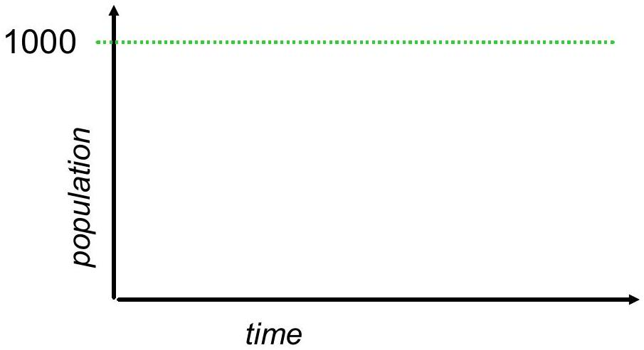

EX 1:
A population begins growing exponentially at a base rate of $6\%$ per year, then follows a logistic growth pattern. If the carrying capacity is 80 million, find the growth rate when the population is 10 million and then again when it is 70 million.

Overshoot and Collapse (model)
In 1944 twenty-nine reindeer were brougt to St. Mathew Island. There was plenty of food and the population increased dramatically. After 20 years, the reindeer had overshot the food carrying capacity of the island. There was a sudden massive die-off. About 99% of the reindeer died of starvation. **
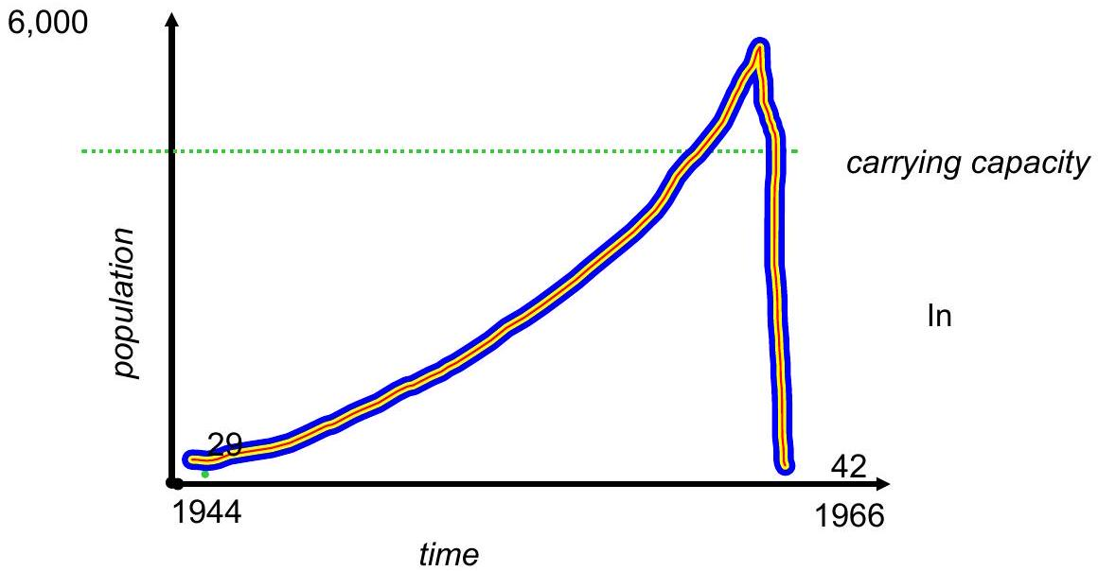
Carrying Capacity depends on
Consumption of resources.
How the average person impacts the environment.

Carrying Capacity can change as the environment or technology changes.

- ** article: http://www.psychologytoday.com/blog/the-how-and-why-sex-differences/201111/how-avoid-population-overshoot-and-collapse

