Math 1030 #15C
More about Carrying Capacity and Logistic Growth

The carrying capacity of a biological species in an environment is the maximum population size of the species that the environment can sustain indefinitely, given the food, habitat, water, and other necessities available in the environment.
The rate of population growth decreases as the population approaches the carrying capacity. If the population equals carrying capacity, the growth rate is 0.
The Logistic Growth Model is based on the assumption that the growth rate decreases smoothly and becomes 0 when the carrying capacity is reached.
$$\begin{matrix}lgr=r⋅\left(1-\frac{ \text{population} }{ \text{carrying capacity} }\right) \\ lgr= \text{logistic growth rate} \\ r= \text{initial} / \text{base/overall growth rate} \end{matrix}$$

A graph of what logistic growth looks like:
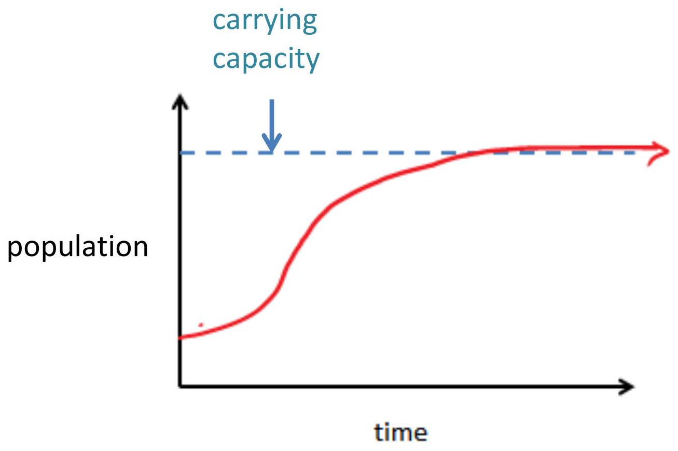

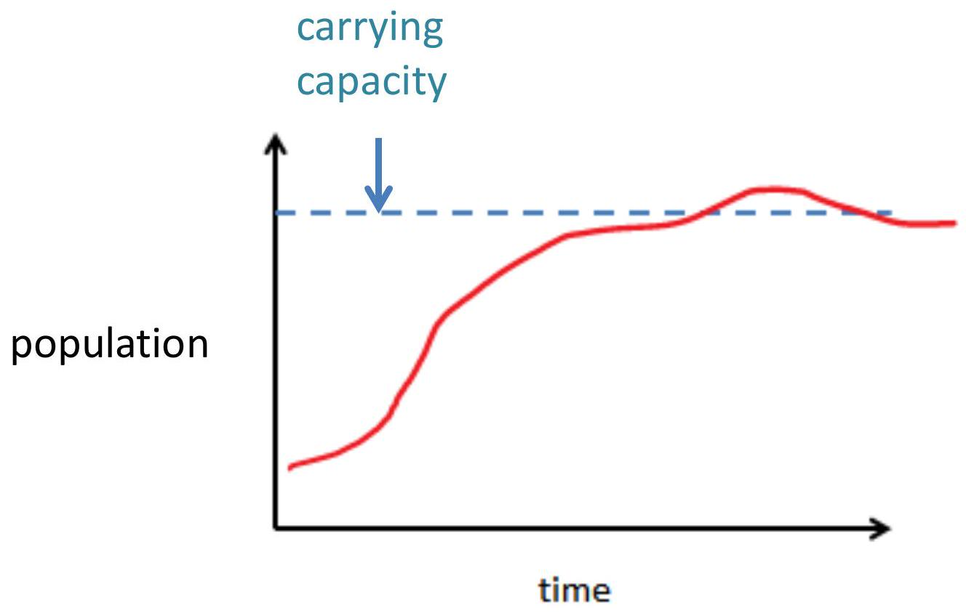
The carrying capacity of Earth is number of people that Earth can support for long period of time.
If the population of earth is logistic, the rate of population growth will slow as the carrying capacity is approached.

Ex 1:
The earth's population appears to have been growing logistically since 1960. If the base growth rate was $2.80\%$, the current population is 7.74 billion and the current growth rate is $1.08\%$, what would the projected carrying capacity be?
$$lgr=r⋅\left(1-\frac{ \text{population} }{ \text{carrying capacity} }\right)$$

Ex 2
Suppose the population a population of bacteria in a petri dish has a base growth rate of $15\%$. The carrying capacity of the petri dish is 90 billion bacteria. Assume that this bacterial growth can be modeled with a logistic growth model.
- What is the growth rate when there are 50 billion bacteria?
$$lgr=r⋅\left(1-\frac{ \text{population} }{ \text{carrying capacity} }\right)$$
- Is the growth rate higher of lower than the answer for part a. when there are 40 billion bacteria? 90 billion?
- Suppose the population is 95 billion. Find and interpret the growth rate.

