Math 1030 #16b
Exponential Modeling
Graphing Exponential Functions
The easiest way to graph exponential functions is to use points corresponding to several doubling times (or half-lives in the case of decay).

For growth:
Start at ( $0,Q_{0}$ )
Plot $\left(T_{\text{double} },2Q_{0}\right)$,
$\left(2T_{\text{double} },4Q_{0}\right)$,
( $3T_{\text{double} },8Q_{0}$ ), etc.
$$T_{\text{double} }=\frac{\log_{10}{2}}{\log_{10}\left(1+r\right)} \\ r>0$$

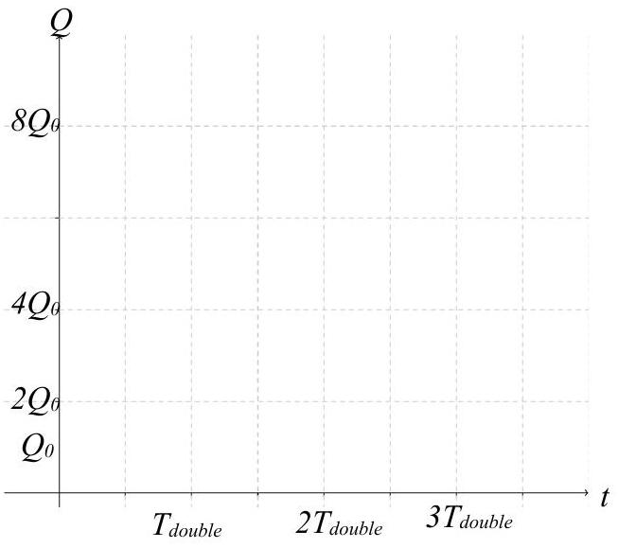

For decay:
Start at ( $0,Q_{0}$ )
Plot $\left(T_{\text{half} },\frac{1}{2}Q_{0}\right)$,
$\left(2T_{\text{hals} },\frac{1}{4}Q_{0}\right)$,
( $3T_{\text{half} },\frac{1}{8}Q_{0}$ ), etc.
$$\begin{matrix} & T_{\text{half} }=-\frac{\log_{10}⁡2}{\log_{10}⁡(1+r)} \\ & r<0\end{matrix}$$

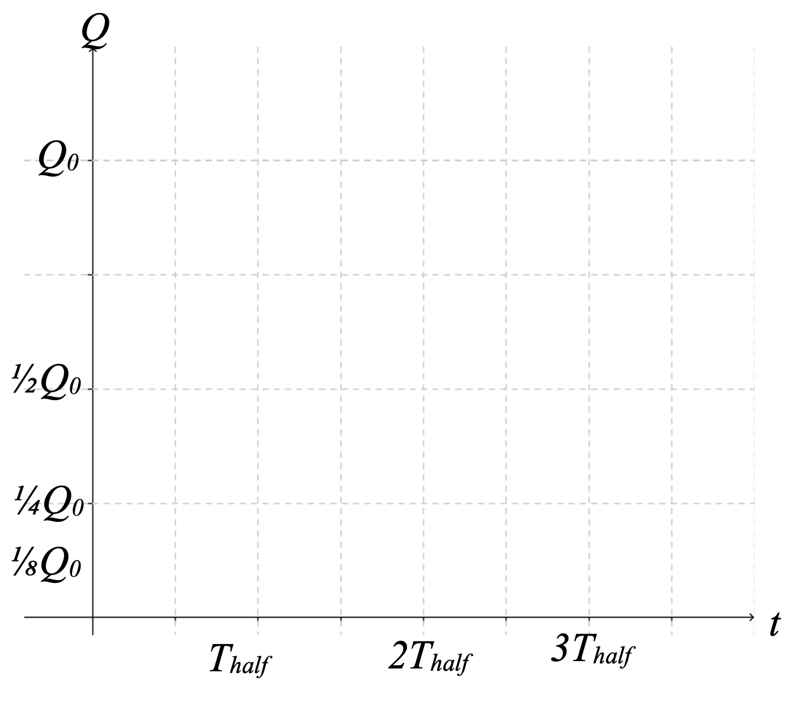

EX 1:
Graph the following equations from the previous lesson.
- The growth of the population of Heber, Utah is $Q=20,000(1.15)^{t}$
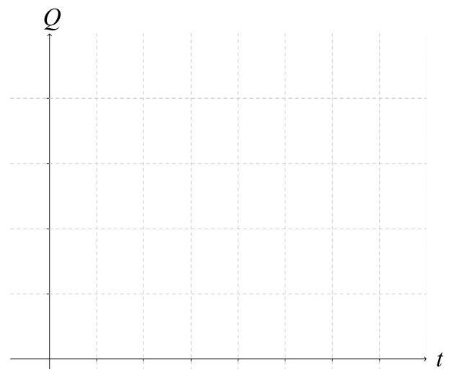

- The decline of the population of Cook Islands is $Q=11,000(0.97)^{t}$
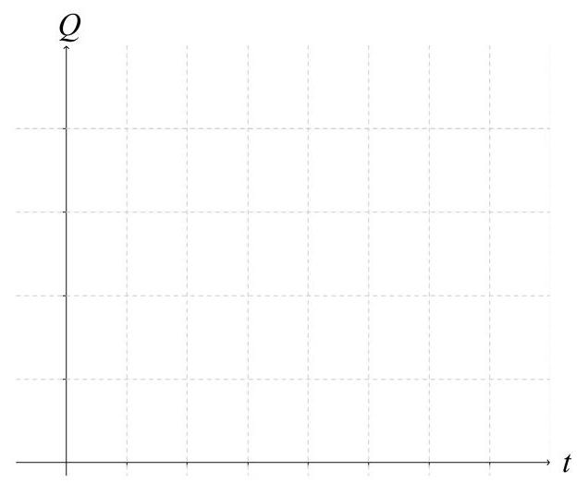

Alternate Forms of the Exponential Function
$Q=Q_{0_{x}}(1+r)^{t}$ Note: $r$ is positive for growth and negative for decay.

$$Q=Q_{0}(2)^{t/T_{\text{double} }} \text{for growth}$$

$$Q=Q_{0}(1/2)^{t/T_{\text{half} }} \text{for decay}$$

EX 2:
If the half-life of a certain Antibiotics in the bloodstream is 10 -hours. If you are given a 15 mg shot at midnight, write an equation for and sketch a graph showing the amount in your bloodstream for the next 24 hours.
