Math 1030 #16D
Using Roots to Find Rates

Exponential Decay and Growth:
$Q=Q_{0}(1-r)^{t}$ $Q=Q_{0}(1+r)^{t}$
$Q_{0}=$ initial amount,$Q=$ final amount,$r=$ rate,$t=$ time
Use different techniques to find different parts of the model:
- Use division to find $Q_{0}$ :
Ex: $700=Q_{0}(1-0.03)^{8}$
- Take logs of both sides to find $t$ :
$$\text{Ex:} 700=200(1+0.03)^{t}$$
- Take roots of both sides to find $r$ :
$$\text{Ex:} 700=200(1+r)^{8}$$

Example 1: Solve the equations
- $x^{2}=16$
- $x^{5}=32$
- $x^{5}=33$
- $(x-2)^{9}=2500$
- $700=200(1+r)^{8}$
Look for calculation error in video in last step of 1d. It is corrected in post notes.
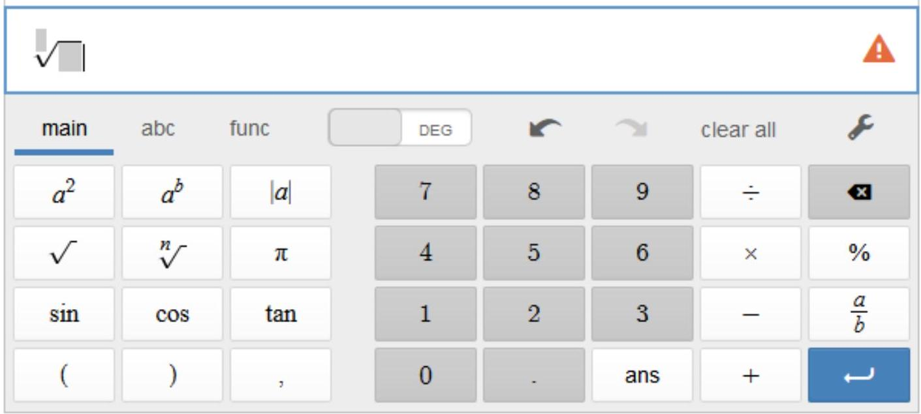
Roots and Fractional Exponents
- Exponent Properties: $\left(7^{2}\right)\left(7^{3}\right)=(7⋅7)(7⋅7⋅7)=7^{5}$
$$\left(7^{2}\right)\left(7^{3}\right)=7^{2+3}=7^{5}$$
- Fractional Exponents: $\left(7^{1/2}\right)\left(7^{1/2}\right)=7^{1/2+1/2}=7$
- Square Roots: $(\sqrt{7})(\sqrt{7})=7$
- Root-Fractional Exponent Connection:
$$\begin{matrix} & \sqrt{7}=7^{1/2} \\ & \sqrt[2]{7}=7^{1/2} \\ & \sqrt[n]{x}=x^{1/n}\end{matrix}$$

Ex 2:
Rewrite the following with rational exponents, then calculate them.
- $\sqrt[3]{10}$
- $\sqrt[4]{81}$
- $\sqrt[25]{1000}$

Ex 3:
In 1990, the population of a city was 20,000. In 2016, the population had grown to 60,000. Find the average annual rate of growth.

Ex 4:
A drug has a half life in the body of 14 hours. Find the hourly rate of decay.

