Math 1030 #17b
Fundamentals of Geometry
Plane Geometry
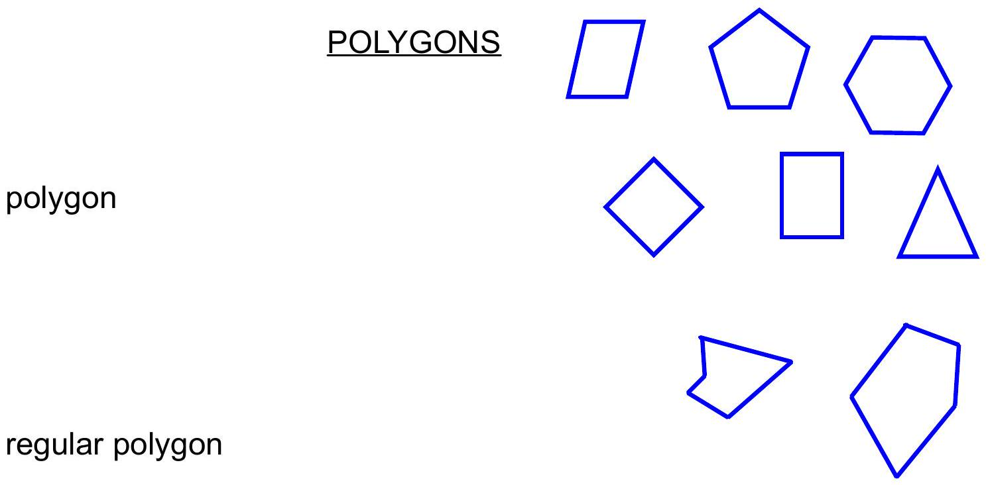

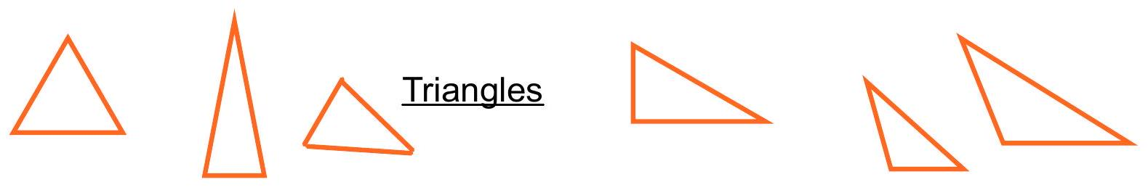

Side length adjectives | Angle adjectives
Equilateral | Obtuse
Isosceles | Acute
Scalene | Right

Perimeter and Area of Polygons

Perimeter

Area

 | Perimeter | Area









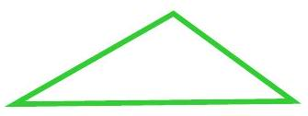

EX 1:
Determine the perimeter and area of each of these.

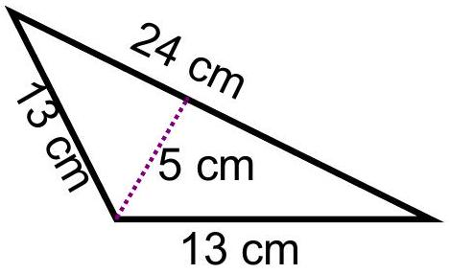

- An envelope with length of 8 inches and width of 14 inches.
- A round stadium with diameter of 1.5 dm.

EX 2:
Determine the area and perimeter of these shapes.
- Assume this is made up of a square and a circle (cut in half)
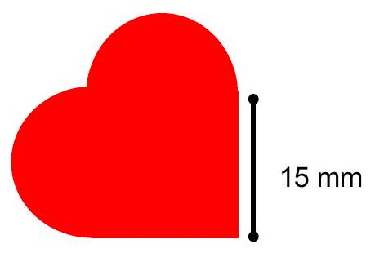

- This is a semicircle on an isosceles triangle.
