Math 1030 #17c
Fundamentals of Geometry
3-D Geometry

A Few Formulas

 | Surface Area | Volume
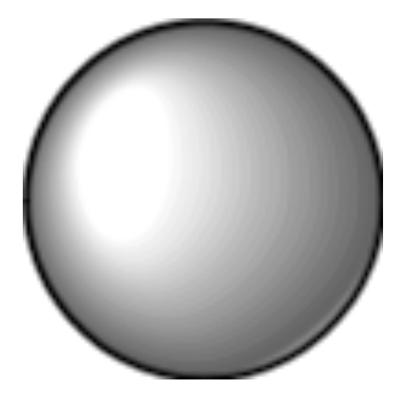 | $$S=4πr^{2}$$ | $$V=4/3πr^{3}$$
 | $S=$ sum of area of all sides | $V=Bh$ (area of the base•height)
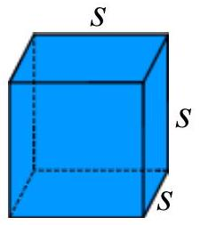
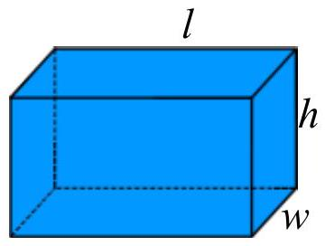
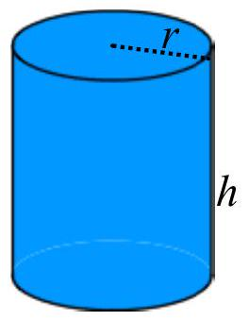

EX 1:
A warehouse sells cylindrical tanks in these dimensions: radius 40 ft and height 80 ft radius 5 ft and height 8 ft.
- How many of the smaller tanks would you need to purchase to hold the same amount as one of the larger tanks?
- Compare the surface area of the larger tank to the total surface area of all the smaller tanks.

EX 2:
I want to fill this box with skittles for a gift.
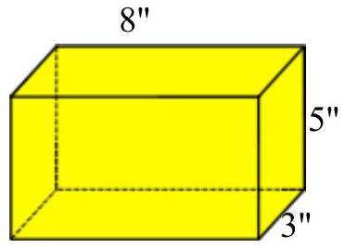

- How much paper will it take to just cover the box (in square inches)?
- How many skittles will it hold, assuming there are 32 skittles per cubic inch?
- If I want to tape the box in all three directions, how much tape will it take?
