Math 1030 #17d
Fundamentals of Geometry
Scaling
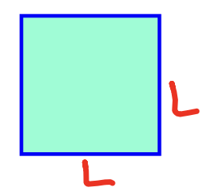 $\begin{matrix} & P=4L \\ & A=L^{2}\end{matrix}$
 | double | triple | quintuple
L
P
A

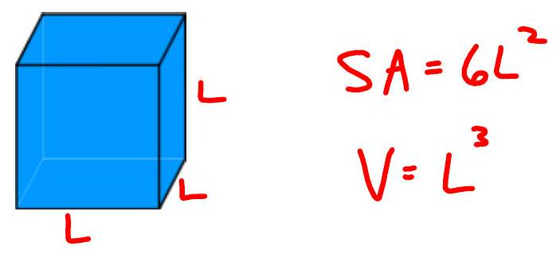
 | double | triple | quintuple
L
SA
V

Scaling a 2D Object

EX 1:
If you triple all sides of a $3-ft$ by $5-ft$ patio, how do the area and perimeter of the new patio compare with the old?


Scaling a 3D Object

EX 2:
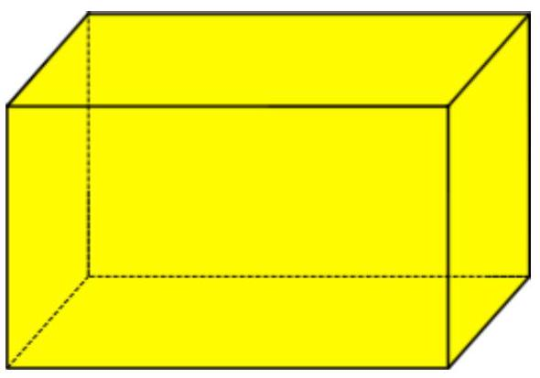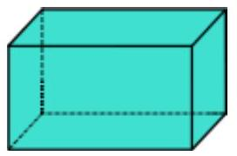

- If the smaller box above can be painted with 2 cans of paint, how many cans will it take to paint a similar box with dimensions four times as large?
- If the larger box holds 512 cubic centimeters of styrofoam pebbles, how much will the smaller box hold?
- If one wants to tape the larger box in all 3 directions, how much more tape must one have than it took to tape the smaller one?

EX 3:
A model version of a T-Rex is 2 feet tall with a surface area of 3 square feet and volume of 1 cubic foot. If the actual T-Rex (which is proportionally identical to the model) is 18 feet tall, what is the volume and surface area?
