Math 1030 #18a
Problem Solving with Geometry
Angles

Degrees, Minutes, Seconds
$1^{∘}={60}^{'}$ There are sixty minutes in a degree.
$1^{'}={60}^{''}$ There are sixty seconds in a minute.

EX 1:
Convert ${47.67}^{∘}$ to degree-minutes-seconds.

EX 2:
Convert ${150}^{∘}{15}^{'}{27}^{''}$ to decimal degrees.

Latitude and Longitude
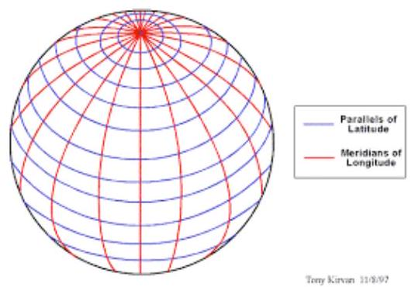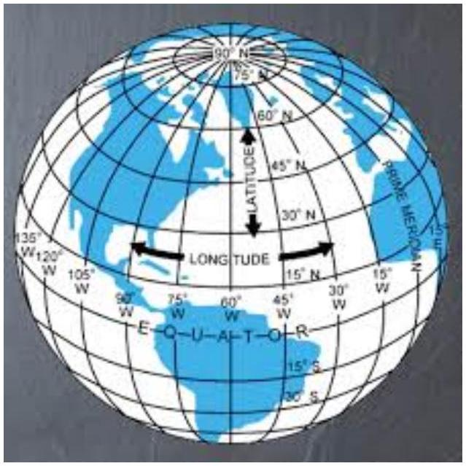
Latitude measures positions north or south of the equator. It will be a number between $0^{∘}$ and ${90}^{∘}$.
Longitude measures east-west position from the prime meridian. It will be a number between $0^{∘}$ and ${180}^{∘}$.

EX 3:
Determine the approximate latitude and longitude of the following places.
- The Panama Canal
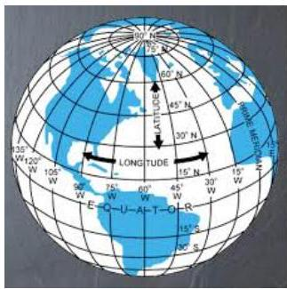
- The eastern most point in South America

- The western most point in Alaska.
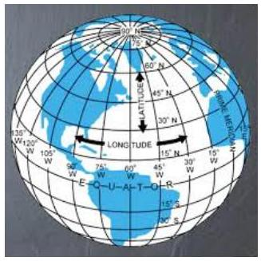

Angular Size and Distance
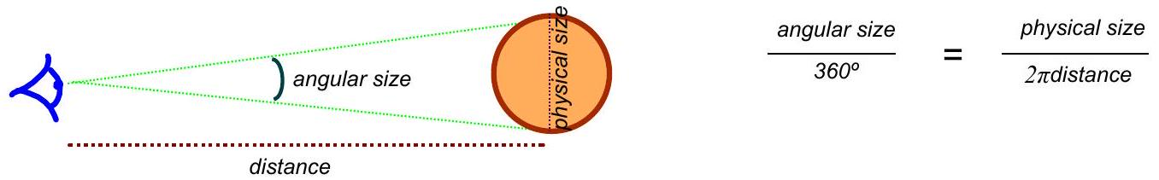

EX 4:
The moon has an angular size of 30 minutes (${0.5}^{∘}$) and its distance from the earth is about 240,000 miles.
- What is the diameter of the moon?
- At what distance would a tennis ball (2.5" diameter) have to be so it would have the same angular size as the moon?
- What is the angular size of the tennis ball when held at arm's length from the eye (about ${25}^{''}$)?
- How far from Washington's face (60 ft in diameter) would you have to stand to have the tennis ball, held at arm's length, barely cover the face?
