Math 1030 #18c
Problem Solving with Geometry
Triangles

Pythagorean Theorem: In a right triangle, the square of the hypotenuse is equal to the sums of the squares of the two legs.
$$a^{2}+b^{2}=c^{2}$$
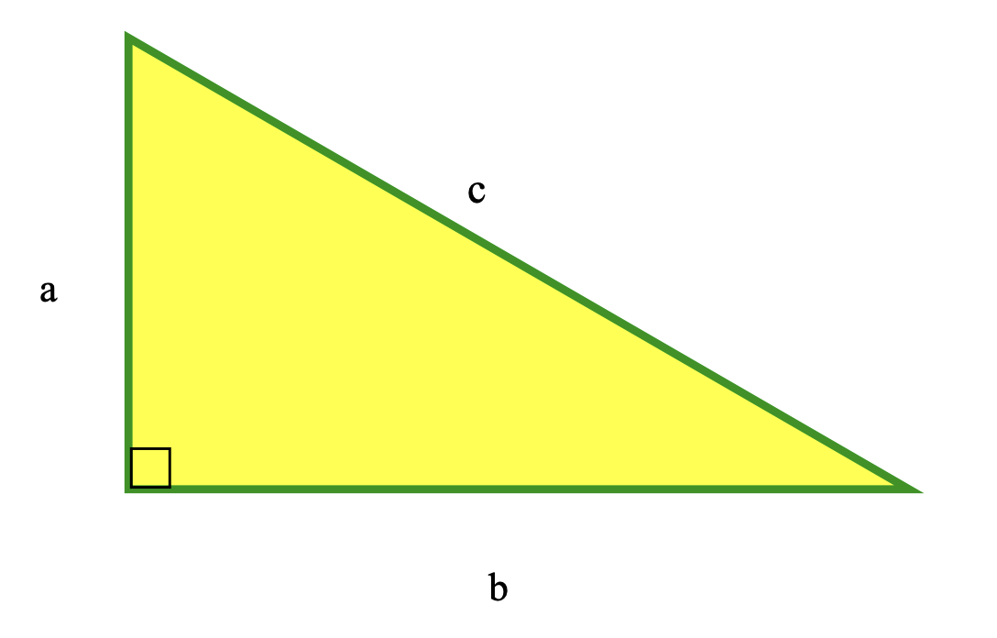

EX 1:
Determine the acres in this piece of river front property. 1 acre $=43,560{ft}^{2}$.
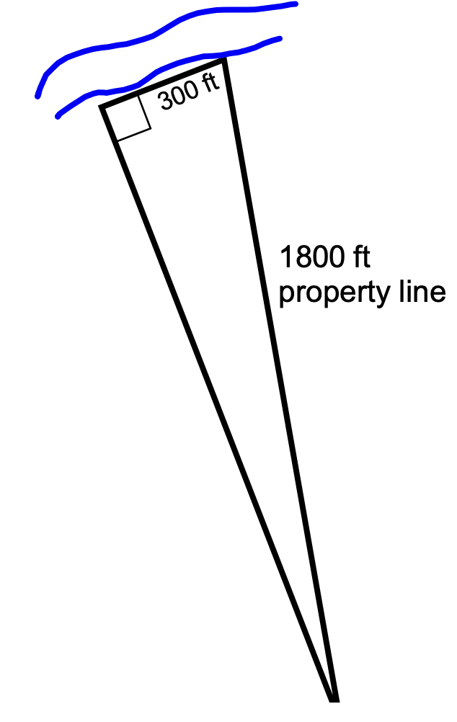

Similar Triangles
Similar triangles have the same shape. Their corresponding angles are equal in measure. Their sides are proportional. That is, the ratios of corresponding sides are equal.
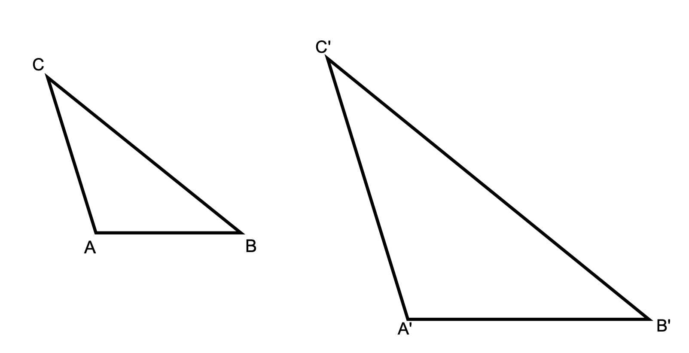

EX 2:
If the sides of the smaller triangle above are (from shortest to longest) $8 cm,b cm,12 cm$ and the sides of the larger triangle are $c^{'}cm,15 cm$ and 20 cm, find the measures of all sides of both triangles.

EX 3:
The shadow cast by a 5 ft 8 inch person is 8 ft. How tall is the light post which casts a 12 foot shadow?

EX 4:
If a skateboard ramp is to have a slope of $5/12$ and takes the skater from ground level to ten feet high, how long is the board necessary to do that?

