Math 1030 #18d
Problem Solving with Geometry

Optimization
Optimization problems seek "best solutions" to various problems.

Ex 1)
If each of these shapes has a perimeter of 16 ft, put them in order of area from least to greatest.
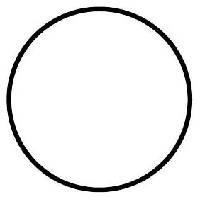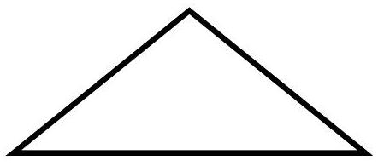
Circle Square Isosceles triangle with sides $5^{'},5^{'}6^{'}$

EX 2:
You are to design a rectangular box with a volume of $64{ft}^{3}$.
- Draw three sample boxes that fit the requirements.
- Determine the surface area of each.
- State the price of each if the materials cost $\$3.00/{ft}^{2}$.

