Math 1030 #1a

Sets ~ Vocabulary
Set

element

subset

disjoint sets

overlapping sets

EX 1: List some elements of these sets.
a) First letter of the days of the week

b) Colors

c) Integers between $-π$ and 7.3

d) Multiples of 3

Venn Diagram $∼$ A visual way to represent the relationship between sets.

EX 2: Draw a Venn Diagram that represent these pairs of sets.

- Nurses and skydivers

- Limericks and poems
- Navy Seals and Green Berets
- Hockey players, figure skaters, women
- Blue vehicles, sedans, trucks

A typical Venn Diagram
$U=$ The universe
$A∪B$ The union of two sets.
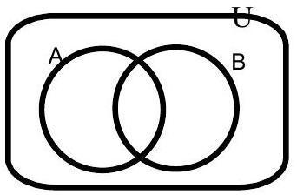
$A∩B$ The intersection of two sets.
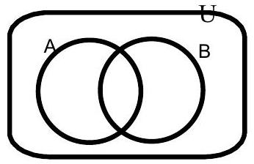

$\overline{A}$ The complement of the set.
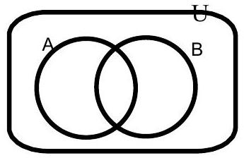

EX 3: Determine how many are in each region of this Venn Diagram
Fifty people were surveyed about a certain political ad.
30 said they saw it on TV.
25 heard it on the radio.
12 did not see or hear the ad at all.
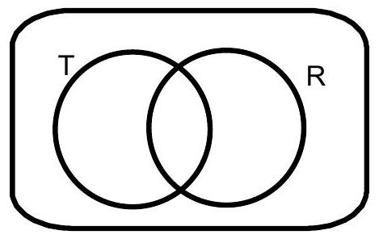
How many are in the intersection of T and R?
How many are in the union of T and R?
How many are in the complement of $R$?

