Math 1030 #1c

EX 1: A Venn Diagram with three circles.
Among Ben Franklin's inventions are the lightning rod, the Franklin Stove and the Carriage odometer. In an old survey of 125 people, it was found that:
- 56 people had a Franklin Stove
- 70 people had a lightning rod
- 30 had a lightning rod and carriage odometer
- 25 had a lightning rod and a Franklin Stove
- 15 people had a carriage odometer and a Franklin Stove
- 4 people had all three inventions
- 70 people did not own a carriage odometer
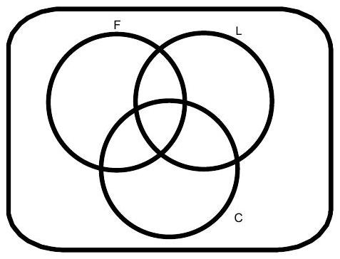
How many people owned a carriage odometer?
How many people owned none of his inventions?
How many owned a lightning rod or a Franklin Stove?
How many owned exactly two of his inventions?

EX 2: Let's make a Venn Diagram of the Real number system.


Place each number in the correct area of the Venn Diagram.
