Math 1030 #2c
Venn Diagrams and Testing Validity
Use Venn Diagrams to Analyze Deductive Arguments

Basic Process
(Variation on Process in the Math 1030 Videos and Textbook)
- Represent the premises AND the conclusion with Venn Diagrams.
- Compare the Venn Diagrams to determine validity
  - The Venn Diagrams agree → valid.
  - The Venn Diagrams do not agree → invalid.
- Determine soundness
  - If an argument is valid, consider whether the premises are true (don't need the Venn Diagram for this.)
    - Yes → the argument is sound
    - No → the argument is not sound
  - If an argument is invalid, it is automatically not sound.

EX 1:
Represent the information in the premises and in the conclusion with separate Venn Diagrams. Then determine the validity and soundness of the argument and explain your reasoning.
- Premise: Residents of Honolulu live on an island.
Premise: Jess lives on an island.
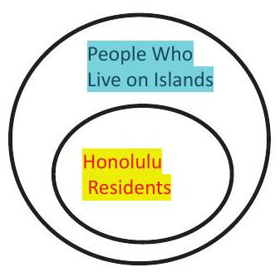 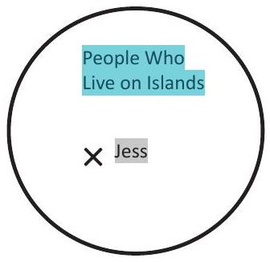
Conclusion: Jess: lives in Honolulu.
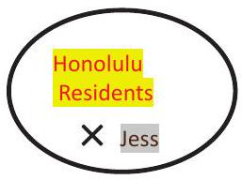
Analysis and explanation:

- Premise: All Japanese cities are on islands.
Premise: Tokyo is a city in Japan.
Conclusion: Tokyo is on an island.
VD for Premises | VD for Conclusion | Analysis and Explanation
- Premise: Everything in space is a star.
Premise: Pluto is in space.
Conclusion: Pluto is a star.
VD for Premises | VD for Conclusion | Analysis and Explanation

EX 2:
Statements with negation
Represent the information with Venn Diagrams. Then determine the validity and soundness of the argument and explain your reasoning.
- Premise: Moths only eat textiles made of natural fibers.
Premise: Polyester is not a natural fiber.
Conclusion: Moths will not eat polyester.
VD for Premises | VD for Conclusion | Analysis and Explanation

- (Example also shown in Video 2B)
Premise: If a figure is a quadrilateral, it has four sides.
Premise: Triangles are not quadrilaterals.
Conclusion: Triangles do not have four sides.
VD for Premises | VD for Conclusion | Analysis and Explanation

