Math 1030 #4a
Solving Problems with Units
US vs Metric Units
What quantities do we measure and what units do we use?
 | Customary units | Metric system
length & distance
volume
weight (mass)

Here are a few commonly used conversions between Metric and USCS measurements:
$$\begin{matrix}1in≈2.540 cm & 1oz≈28.3495 g & 1qt≈0.9464 \text{liter} \\ 1yd≈0.9144 m & 1lb≈0.4536 kg & \\ 1mi≈1.6093 km & & \end{matrix}$$

EX 1:
- How many liters are in a 6 -pack of 12 -oz cans of pop?
- If you go $100 km/hr$ in your Porsche, what is the speed in mph?
- If water sells for $\$2.00$ per quart and soda sells for $\$0.99$ per 2-liter bottle, how much more expensive is water?

Temperature
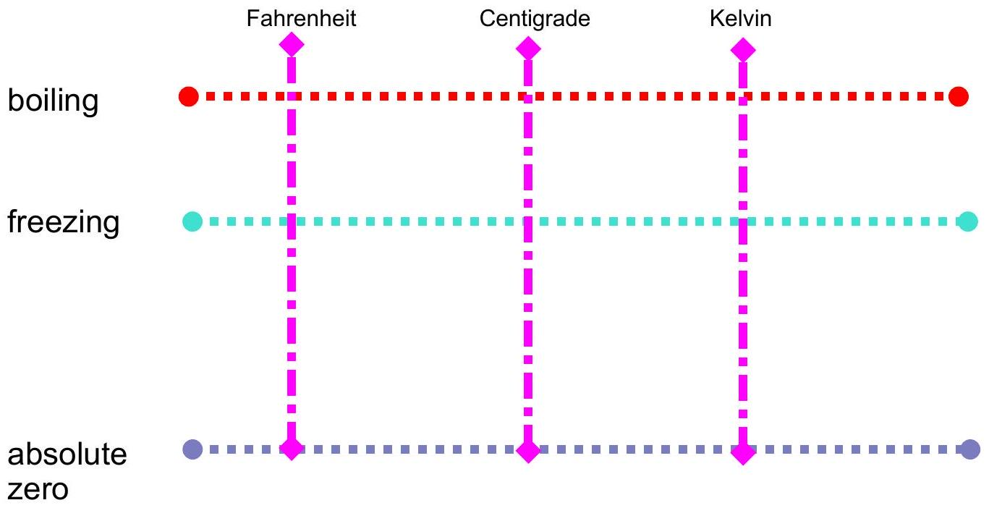
Formulas:
$$\begin{matrix}F=1.8C+32 & ⇔ & C=\frac{F-32}{1.8}=\frac{5}{9}(F-32) \\ K=C+273.5 & ⇔ & C=K-273.5\end{matrix}$$

EX 2:
- Our normal body temperature is ${98.6}^{∘}F$. What is this in Centigrade?
- The average temperature of Madrid, Spain ranges from $0^{∘}C$ to ${32}^{∘}C$. How do these compare with Salt Lake City ( ${21}^{∘}F$ to ${91}^{∘}F$ ) which is close to the same latitude of ${41}^{∘}N$ ?

