Math 1030 #6b

Putting numbers in Perspective

Scaling

Perspective Through Scaling
Scale may be expressed
Verbally - $1 cm=1mi$
Graphically - Marked miniruler on a map.
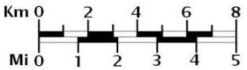
As a ratio - The model of the home was 1:64
We use scales in
Maps, Design, Timelines, Time-lapsed photography

EX 1:
According to modern science, Earth is about 4.5 billion years old. Written human history extends back 10,000 years. Suppose you represent the entire history of the Earth by 12 hours on a clock, with the birth of Earth at midnight.
- How much time on the clock represents a billion years?
- At what time on the clock does written human history begin?

EX 2:
There are approximately 2.2 million marriages per year in the United States. Express this quantity in marriages per hour.

EX 3:
In 2007, Proctor and Gamble spent $\$5.2$ billion on advertising. Express this quantity in terms of the height in kilometers of a stack of $\$1.00$ bills. Assume 10 bills per millimeter.

EX 4:
The debt ceiling is $\$14.294$ trillion. How big is that number?

