Math 1060 ~ Trigonometry

Review of the Concept of Inverse Functions

Reminders About a Function and Its Inverse
- The inverse of a function, $f(x)$, is written $f^{-1}(x)(readf$-inverse).
- The -1 is NOT an exponent.
- The original function must be 1 -to-1.
- The graph of $y=f^{-1}(x)$ (the inverse function) is a reflection of $y=f(x)$ across the line $y=x$.
- An $(a,b)$ point on the graph of the function becomes a $(b,a)$ point on the graph of the inverse function.
- The domain of $f^{-1}(x)$ is the range of $f(x)$ and vice versa.
- $f\left(f^{-1}(x)\right)=f^{-1}(f(x))=x$ for every $x$ in the domain of $f$.

Let's demonstrate this with $f(x)=x^{2}$ and its inverse function.
$$f(x)=x^{2}$$
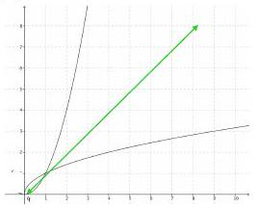
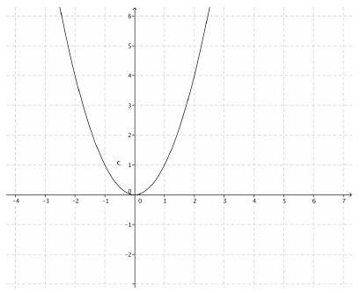
$$f(x)=x^{2},x≥0$$

$$f\left(x\right)=x^{2},x≤0$$
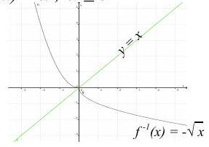

For the quadratic function, $f(x)=x^{2},x≥0$, the inverse function is $f^{-1}(x)=\sqrt{x}$

EX 1
Answer each of these:

1a)
What number can I square to get 4?

1b)
If $x^{2}=4$, then $x=$

1c)
$\sqrt{4}=$

1d)
What is the principal square root of 4?

1e)
List all square roots of four.

Notice that the way the question is asked determines the number of answers. Thus, when we develop inverses for the trigonometric functions, we must consider this.

$$sin⁡x=-\frac{1}{2}⇒x=$$

$$\sin^{-1}⁡\left(-\frac{1}{2}\right)=arcsin⁡\left(-\frac{1}{2}\right)=$$

