Math 1060 ~ Trigonometry

15 The Law of Sines
We will now apply our techniques to oblique triangles, those with no right angle.
It is important to label sides and angles of a triangle in a specific way.
Label the vertices $A,B,C$ and the sides opposite them $a,b,c$ respectively and the angles $α,β,γ$ respectively.
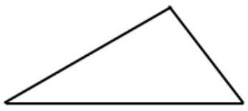
The Law of Sines states that given any triangle $ABC,\frac{a}{sin⁡α}=\frac{b}{sin⁡β}=\frac{c}{sin⁡γ}$.
It may also be stated this way: $\frac{sin⁡α}{a}=\frac{sin⁡β}{b}=\frac{sin⁡γ}{c}$
We will prove it here.
Given: $△ABC$
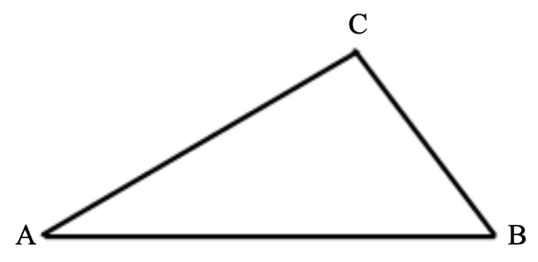
Prove: $\frac{a}{sin⁡α}=\frac{b}{sin⁡β}$

Draw altitude $\overline{CD}⊥\overline{AB}$
Let $CD=h$
In $△ACD,sin⁡α=$
In $△BCD,sin⁡β=$
Solve each for h and set them equal to each other.

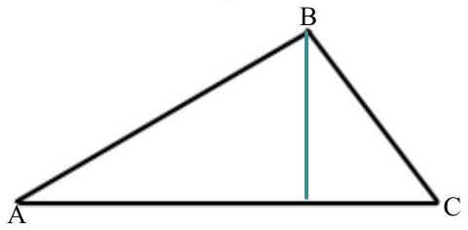
Area of a Triangle:
There are two alternate formulas for the area of a triangle.
We will prove the first one.
$$A=\frac{1}{2}absin⁡γ$$

EX 1
Given triangle KLM, with $m=6 cm$ and the angle at L measuring ${40}^{∘}$ and the angle at K measuring ${75}^{∘}$, solve for the remaining parts of the triangle and find the area.

EX 2
Given triangle PQR , with the angle at P measuring ${120}^{∘}$, the angle at Q measuring ${30}^{∘}$ and $p=10ft$, solve for the remaining parts.

EX 3
Think back to your congruence postulates in Geometry, ASA, AAS, SAS, SSS and identify each problem above with its postulate.

Let's address the dreaded SSA postulate.

EX 4
If $sin⁡(α)=0.5$ in triangle ABC, what is the measure of the angle at vertex A?
Ambiguous Case: Here is an example that leads to two different triangles in the case of SSA.
Given $△ABC$ with $α={40}^{∘},c=10 cm$, and $a=8 cm$, solve for the other parts.
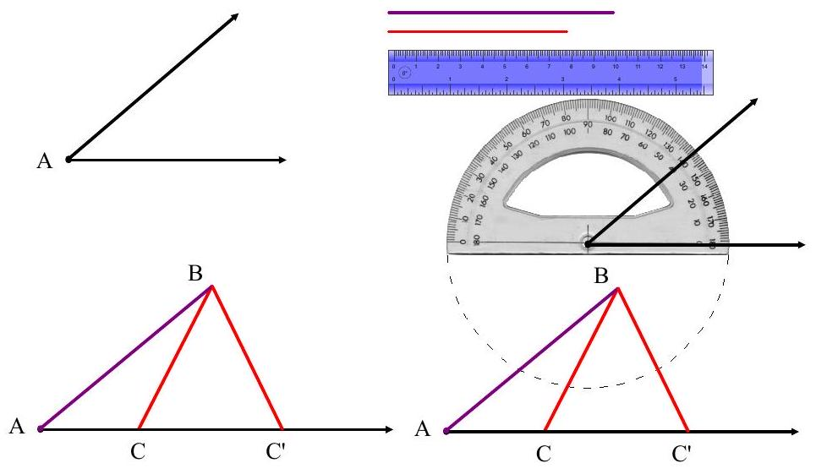

More Ambiguity

EX 5
In the previous example, consider each of these.

5a)
What if $a=2 cm$ ?

5b)
Is there a value for $a$ which
produces exactly one triangle?

5c)
What if $a=10 cm$ ? produces exactly one triangle?
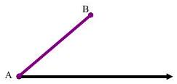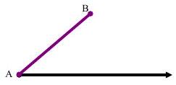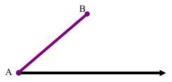

Now think about the other two postulates, SSS and SAS . Can we use the Law of Sines to solve for parts on these?
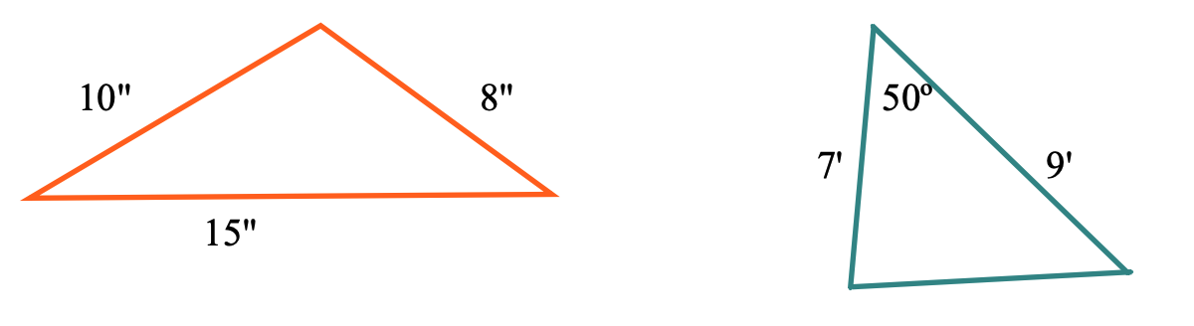
It becomes necessary to have another law.

- ** The app used in this lesson is at this link:
https://www.geogebra.org/m/CvtkyRM5

