Math 1060 ~ Trigonometry

16 Law of Cosines

Congruence Postulates from Geometry
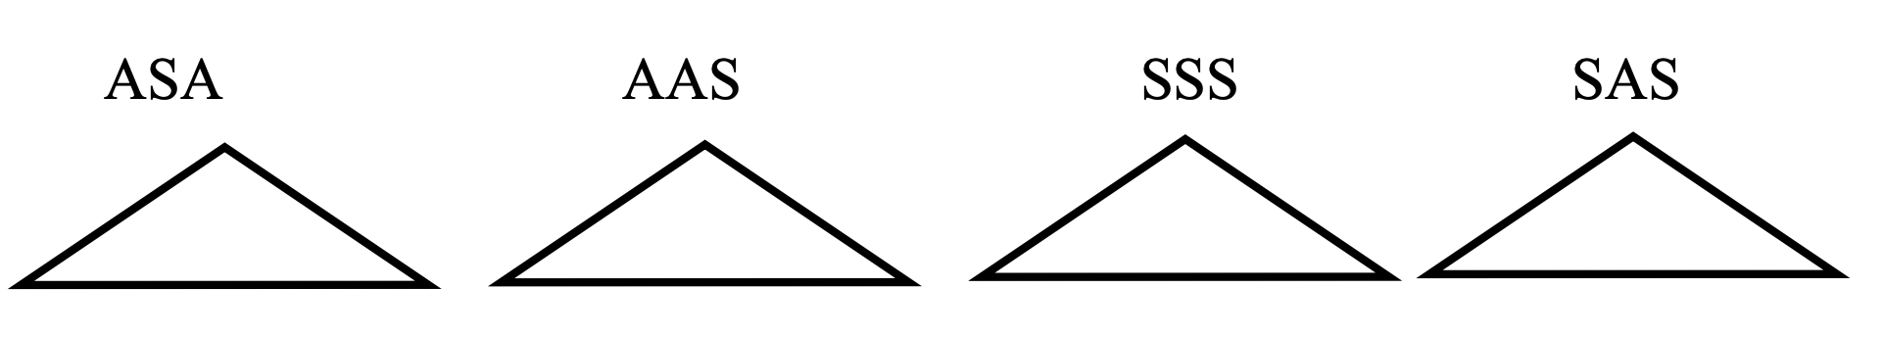

The Law of Cosines is just an adjustment to the Pythagorean Theorem which allows you to apply it to oblique triangles.
In a right triangle with hypotenuse length $c$, | In any triangle with sides lengths of $a,b,c$,
$$c^{2}=a^{2}+b^{2}$$ | $$c^{2}=a^{2}+b^{2}-2abcos⁡γ$$
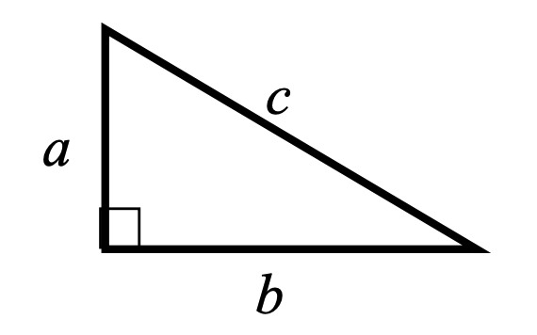 | 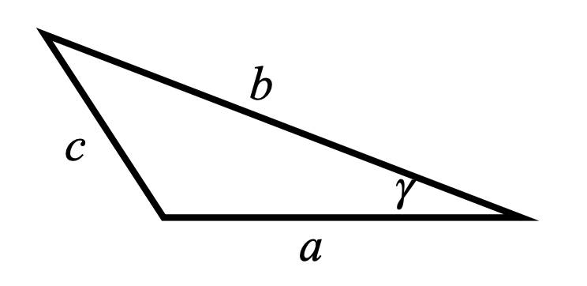

Proof of the Law of Cosines:
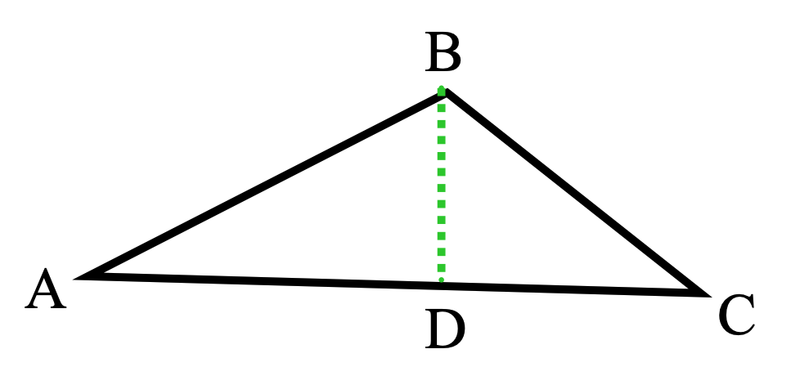
Given: ΔABC
Prove: $c^{2}=a^{2}+b^{2}-2abcos⁡γ$
Draw altitude $\overline{BD}$ to side $\overline{AC}$.
$$BD=h$$

As you work these, write the postulate which applies, SSS, SAS, ASA, AAS.

EX 1
Triangle ABC has $a=15 cm,b=12 cm$, and $γ$ measures ${85}^{∘}$. Solve for the missing parts.

EX 2
Find the angles in a triangle with sides of $6 m,9 m$ and 11 m.
There is one more interesting formula for the area of a triangle given the three sides.
Heron's formula: $A=\sqrt{s\left(s-a\right)\left(s-b\right)\left(s-c\right)}$, $s=\frac{a+b+c}{2}$
The strategy for solving any triangle, given three parts:
- Draw the triangle.
- Label the parts.
- Determine which law to use.
- Solve.

EX 3
A surveyor is measuring the width of a lake. He stands at point A and walks 50 m to point B, turns counter-clockwise ${85}^{∘}$ and walks 75 m to point C. How wide is the lake?
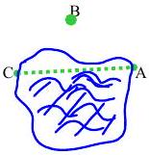

EX 4
Find the area of a triangle with sides $7^{''},{12}^{''}$, and ${13}^{''}$ in two ways:

4a)
Use $A=\frac{1}{2}absin(γ)$

4b)
$A=\sqrt{s\left(s-a\right)\left(s-b\right)\left(s-c\right)}$, $s=\frac{a+b+c}{2}$

EX 5
To estimate the dimensions of a lake, a surveyor starts at point A, walks 100 m to a tree at point B , turns ${75}^{∘}$ clockwise and measures the walk to point C as 70 m. What is the width of the lake from A to C?
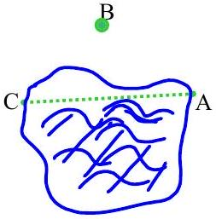

Trigonometry and Bearings
In surveying and navigation, directions are often given in terms of bearings. This can be in one of two ways.
- Expresses as some east or west angle from north or south.
- Expressed as degrees in a clockwise direction from north.

EX 5
Sketch each bearing and express it in both ways.
$$N{50}^{∘}W$$ | $$S{30}^{∘}E$$ | $${200}^{∘}$$ | $${320}^{∘}$$
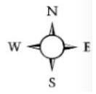

EX 6
A plane flies due north for 200 miles, then turns to a bearing of ${50}^{∘}$ and flies 120 miles. How far is it from the starting point?

