Math 1060 ~ Trigonometry

17 Polar Coordinates and Equations

Rectangular Coordinates
$$(x,y)$$
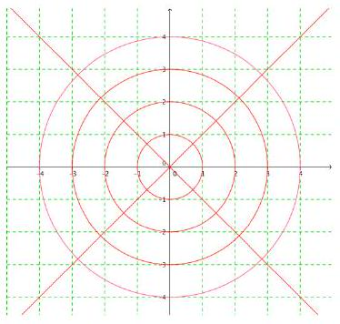

Polar Coordinates
$$(r,θ)$$

In fact:
( $r,θ$ ) has infinitely many representations:
$(r,θ+2nπ)$ and $(-r,θ+(2n+1)π)$, where $n$ is any integer
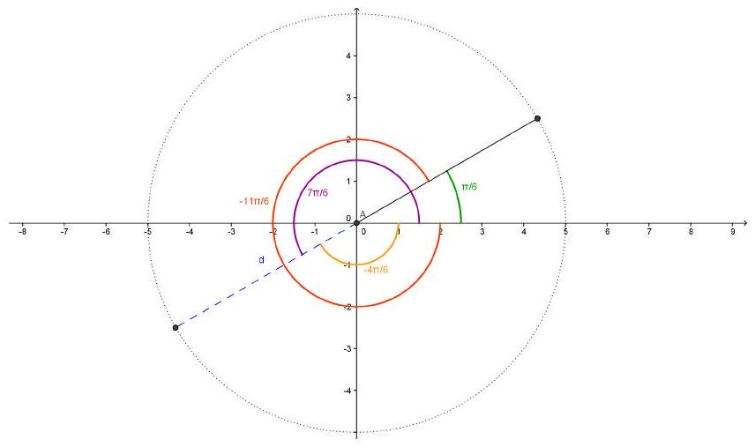

How do we translate between Cartesian and polar coordinates?

Polar to Cartesian:
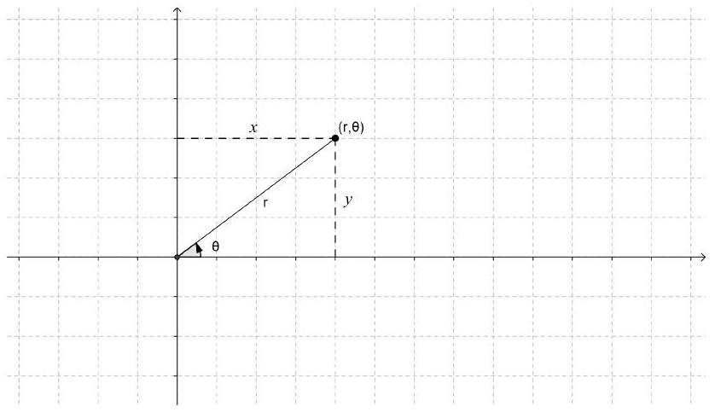

EX 1
Convert $(-4,2π/3)$ to Cartesian coordinates.
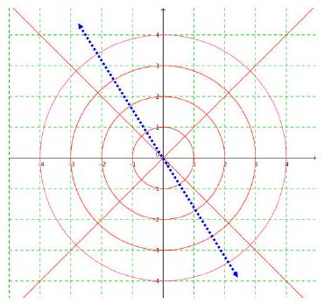

How do we translate between Cartesian and polar coordinates?

Cartesian to polar:
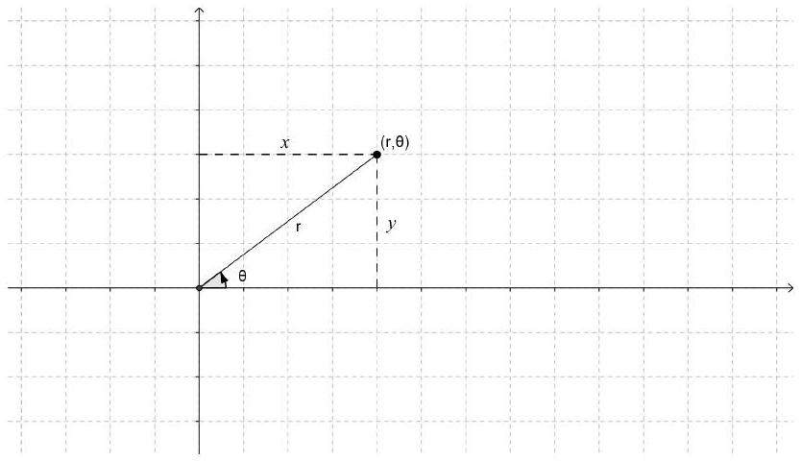

EX 2
Convert $(-2,2)$ to polar coordinates.
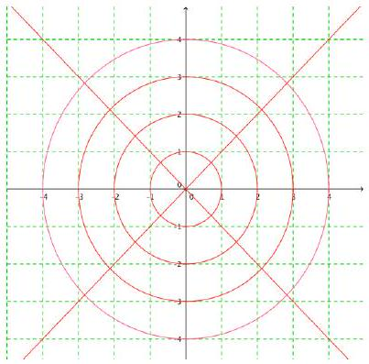

We can convert equations, too!

EX 3

- Convert $x^{2}-3x=1+xy$ into polar coordinates.
- Convert $r=-2cos⁡θ$ into Cartesian coordinates.

