Math 1060 ~ Trigonometry

18 Graphing Polar Equations
What do these equations represent?
$$θ=β$$

$$rcos⁡θ=a$$

$$rsin⁡θ=b$$

What about these?
$$r=2acos⁡θ$$

$$r=2b\sin{θ}$$

$$r=2a\cos{θ}+2b\sin{θ}$$

EX 1
$$r=4cos⁡θ$$
$$θ$$ | 0 | $$π/4$$ | $$π/3$$ | $$π/2$$ | $$2π/3$$ | $$3π/4$$ | $$π$$ | $$5π/4$$ | $$3π/2$$ | $$7π/4$$ | $$2π$$
$$r$$

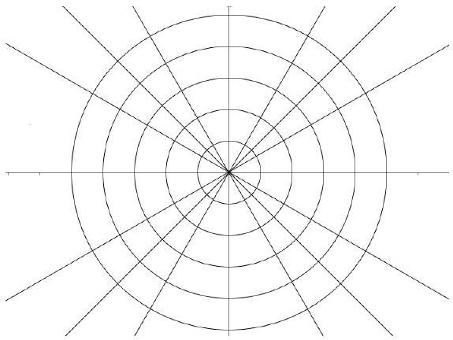

Symmetry

Symmetry with respect to the line θ = π/2
Replace (r, θ) with (r, π-θ) or (-r, -θ): If an equivalent equation results, the graph has this type of symmetry.
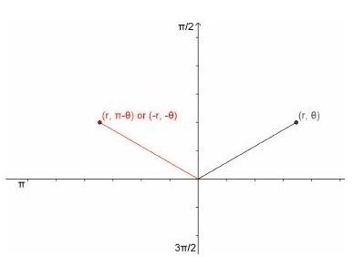

Symmetry with respect to the polar axis (θ = 0):
Replace (r, θ) with (r, -θ) or (-r, π-θ): If an equivalent equation results, the graph has this type of symmetry.
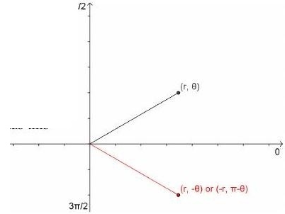

Symmetry with respect to the pole
Replace (r, θ) with (-r, θ) or (r, π+θ): If an equivalent equation results, the graph has this type of symmetry.
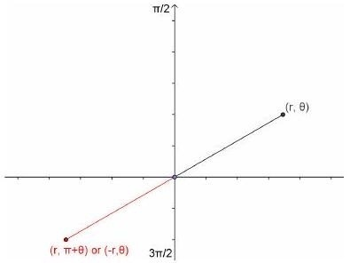
If a polar equation passes a symmetry test, then its graph definitely exhibits that symmetry. However, if a polar equation fails a symmetry test, then its graph may or may not have that kind of symmetry.

Zeros and maximum $r$-values
Other helpful tools in graphing polar equations are knowing the values for θ for which |r| is maximum and those for which r = 0.

EX 2
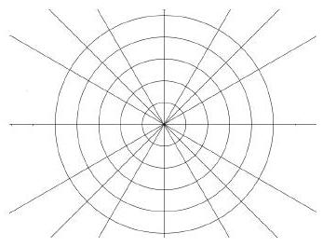
Graph $r=\frac{1}{2}+cosθ$
Symmetry:

|r| maximum:
Zero of r:

Limaçons
$$r=a±b\cos{θ}$$

$r=a±b\sin{θ}$ $a > 0, b > 0$

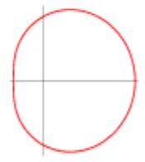 | 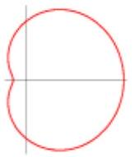 | 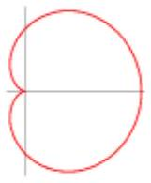 | 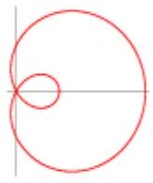
$$\frac{a}{b}≥2$$ | $$1<\frac{a}{b}<2$$ | $$\frac{a}{b}=1$$ | $$\frac{a}{b}<1$$
Convex limaçon | Dimpled limaçon | Cardioid - always passes through pole | Limaçon with inner loop

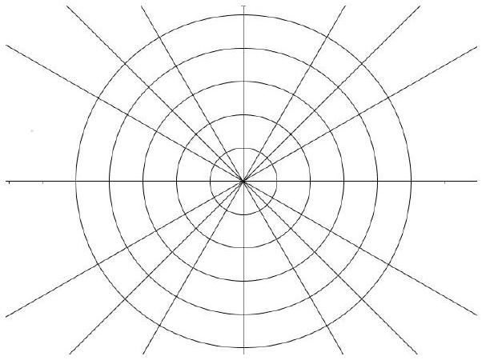
EX 3
Graph r = 3 sin 2θ
Symmetry:

|r| maximum:
Zero of r:

$$θ$$ | 0 | $$π/8$$ | $$π/6$$ | $$π/4$$ | $$π/3$$ | $$π/2$$
$$r$$

Roses
$$r=asin⁡(nθ),$$
or
$$r=acos⁡(nθ)$$
If $n$ is odd, the rose is $n$-petalled. If $n$ is even, the rose is $2n$-petalled.
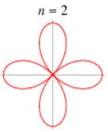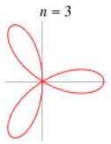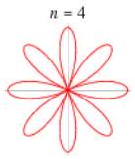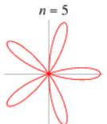

No reason to limit ourselves to $n$ integer:
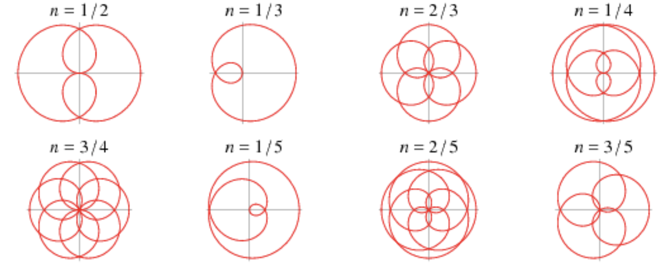
Or even irrational:
