Math 1060 ~ Trigonometry

1 Degree and Radian Measures of Angles

Vocabulary for angles
ray 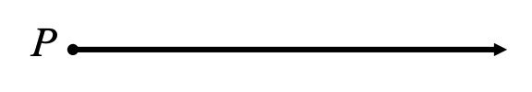

angle 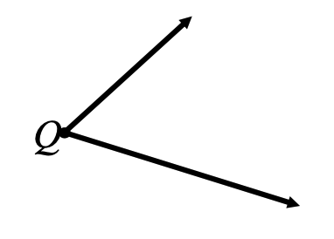

vertex 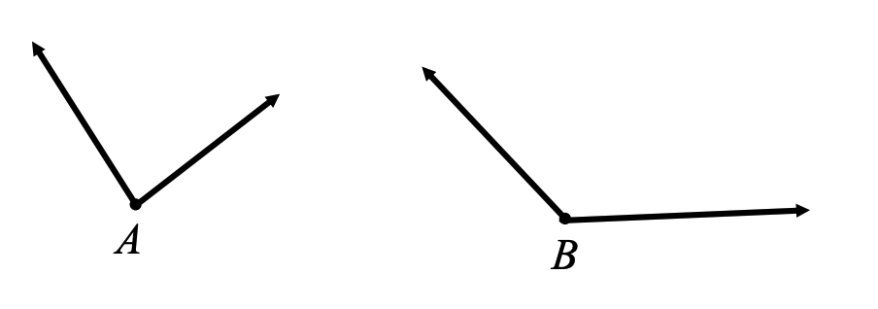

straight angle 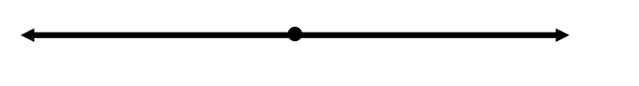

Degree Measure of Angles and Types of Angles
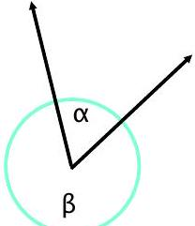

EX 1
State the measure of each of these angles in degrees and describe the type of each.
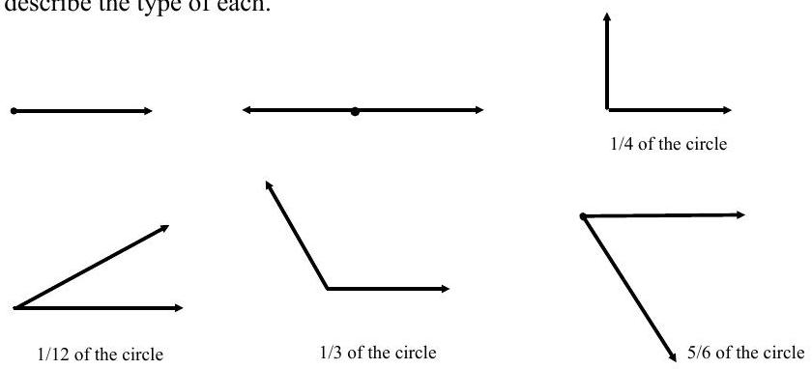

Angles in Standard Position
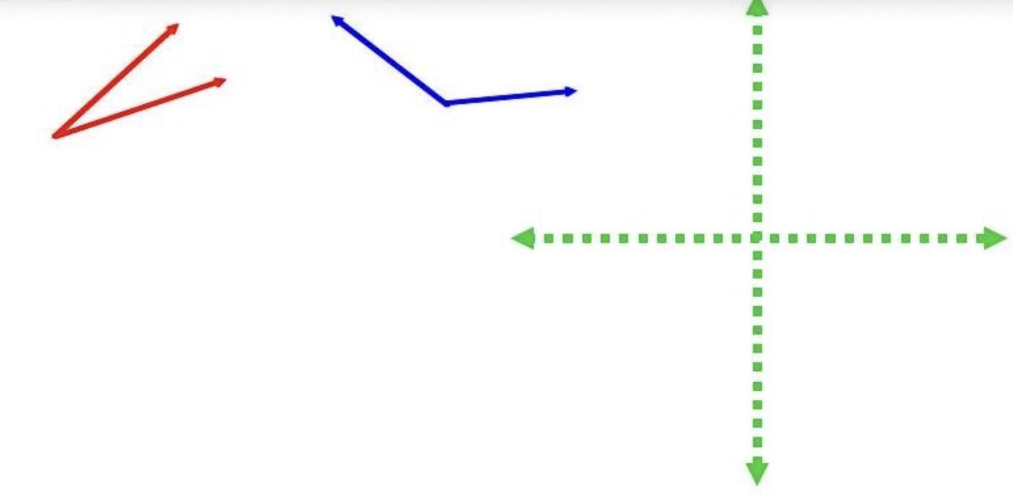

standard position

initial side

terminal side

positive angle

negative angle

coterminal angles

EX 2
State a coterminal angle between $0^{∘}$ and ${360}^{∘}$ for each of these.

2a)
$$α={432}^{∘}$$

2b)
$$β=-{25}^{∘}$$

2c)
$$γ={500}^{∘}$$

2d)
$$θ=-{630}^{∘}$$

Radian Measure of an Angle
What is the number $π$?
A radian is that portion of the circle equal in length to one radius of that circle.
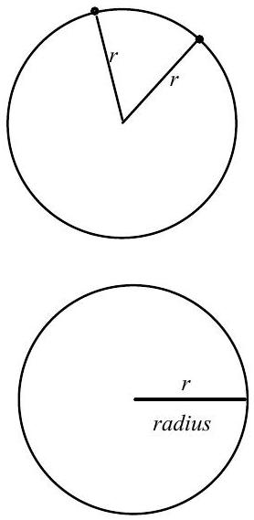$\begin{matrix} & r= \\ & s= \\ & θ=\end{matrix}$
https://en.wikipedia.org/wiki/File:Circle_radians.gif
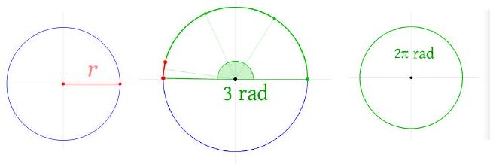

EX 3
Graph each of these angles in standard position and classify them according to where their terminal side lies. State another coterminal angle between $-2π$ and $2π$ for each angle.
$$α=\frac{π}{3}$$ | $$β=-\frac{5π}{6}$$ | $$λ=\frac{π}{2}$$ | $$θ=\frac{9π}{4}$$


Converting Between Degrees and Radians
The conversion factor between degrees and radians is $2π$ radians $={360}^{∘}$.

EX 4
Convert the following measures.

4a)
${225}^{∘}$ to radians

4b)
$-\frac{5π}{6}$ radians to degrees

4c)
2 radians to degrees

4d)
${1080}^{∘}$ to radians

Supplementary and Complementary Angles in Degrees
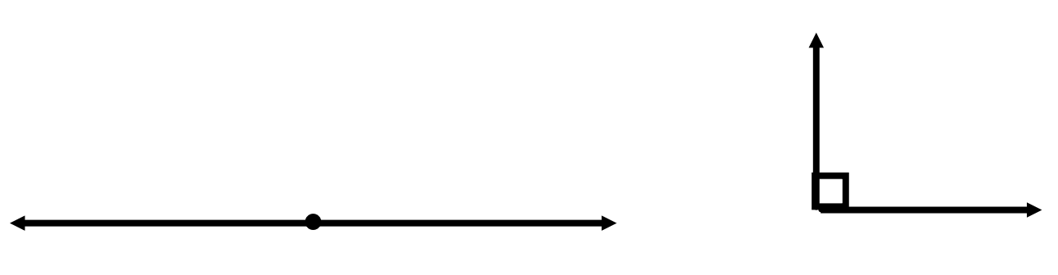

EX 5
Determine the complement and supplement (if they exist) for each of these angles.
angle | complement | supplement
$$α={24}^{∘}$$
$$β={90}^{∘}$$
$$γ={130}^{∘}$$
$$φ={180}^{∘}$$

Supplementary and Complementary Angles in Radians

EX 6
Determine the complement and supplement (if they exist) for each of these angles.
angle | complement | supplement
$$α=\frac{π}{3}$$
$$β=\frac{5π}{6}$$
$$γ=\frac{π}{4}$$
$$φ=π$$

