Math 1060 ~ Trigonometry

23 The Dot Product
The dot product of two vectors is a scalar. It can be useful in finding the angle between two vectors.
If $v=\left\langle v_{1},v_{2}\right\rangle$ and $w=\left\langle w_{1},w_{2}\right\rangle$, then $v*w=v_{1}w_{1}+v_{2}w_{2}$.
Note: $\vec{w}⋅\vec{w}=w_{1}w_{1}+w_{2}w_{2}=w_{1}^{2}+w_{2}^{2}=‖\vec{w}‖^{2} ‖\vec{w}‖^{2}=\vec{w}⋅\vec{w}$

EX 1
Find the dot product of these pairs of vectors.

1a)
$v=⟨3,4⟩$ and $w=⟨-2,5⟩$.

1b)
$v=⟨-3,2⟩$ and $w=⟨-4,-6⟩$

Geometric Interpretation of the Dot Product
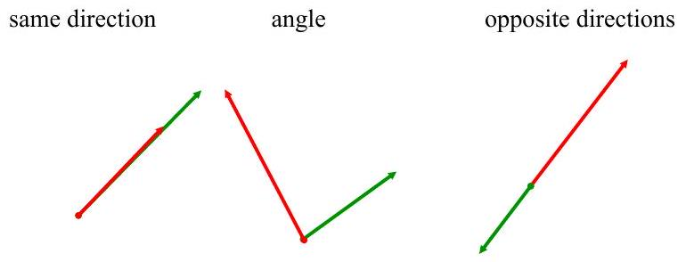
Note: there are move dot product properties
listed in the book to refer to.
We will use the Law of cosines to prove that $v∙w=‖v‖‖w‖cos⁡θ,0<θ<π$.
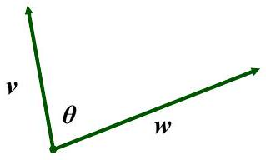

$$ν⋅w=‖ν‖‖w‖cos⁡θ$$

EX 2
Determine the angle between these pairs of vectors.

2a)
$v=⟨3,4⟩$ and $w=⟨-2,5⟩$.

2b)
$v=⟨-3,2⟩$ and $w=⟨-4,-6⟩$

Orthogonal vectors: If two vectors are perpendicular to each other they are said to be orthogonal. What would the cosine of the angle between two orthogonal vectors be?

EX 3
Determine whether these pairs are vectors are orthogonal or not.

3a)
$⟨3,-2⟩$ and $⟨1,4⟩$

3b)
$⟨4,-6⟩$ and $⟨-3,-2⟩$

3c)
$⟨2,-1⟩$ and $⟨-4,2⟩$

Orthogonal Projection
If $v$ and $w$ are nonzero vectors, then the orthogonal projection of $v$ onto $w$, denoted by ${proj}_{w}(v)$ is given by
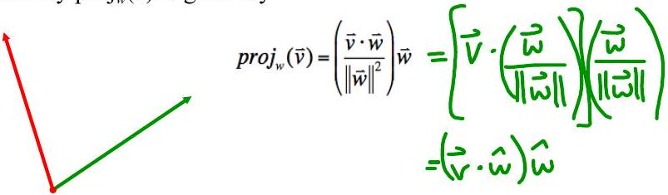

EX 4
For $v=⟨-6,-5⟩$ and $w=⟨10,-8⟩$, find ${proj}_{w}(v)$.
In physics, you will discover how this concept relates to problems about work.

