Math 1060 ~ Trigonometry

24 Curves Described by Parametric Equations

Curves Described by Parametric Equations
The functions describing the curve, $C$, traditionally use $f(t)$ to represent $x$ and $g(t)$ to represent $y$. The independent variable $t$ in this case is called a parameter.
The system of equations $\left\{\begin{matrix}x=f(t) \\ y=g(t)\end{matrix}\right.$
is called a system of parametric equations. The parametrization of $C$ endows it with an orientation and the arrows on $C$ indicate the motion as values of $t$ increase.

For example, this set of equations describes the unit circle, with the arrow indicating the orientation.
$$\left\{\begin{matrix}x=cos⁡t 0≤t≤2π \\ y=sin⁡t\end{matrix}\right.$$
To sketch parametric equations, a chart is often useful.

EX 1
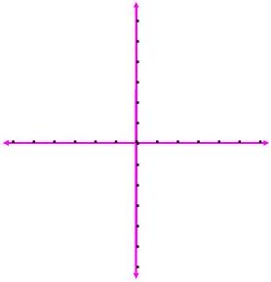
Draw a chart for this set of equations and plot several points.
$$\left\{\begin{matrix}x=2t+1 \\ y=t^{2}-2\end{matrix} t≥-2\right.$$
$$t$$ | $$x(t)=2t+1$$ | $$y(t)=t^{2}-2$$ | $$(x(t),y(t))$$

EX 2
Plot this equation by following these steps.
$$\left\{\begin{matrix}x=-2t^{2} \text{on the interval} [-1,1] \\ y=t^{3}\end{matrix}\right.$$

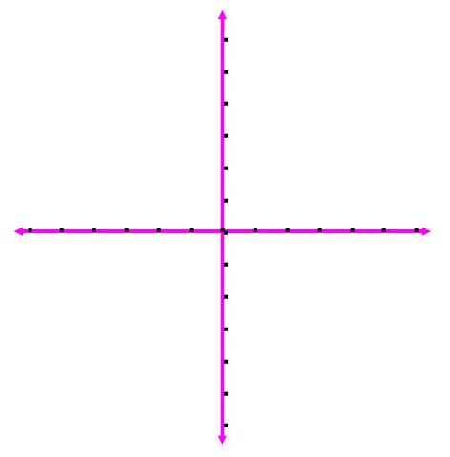
2a)
Make a table of values.

2b)
Plot the points, including orientation.
$$t$$ | $$x(t)$$ | $$y(t)$$ | ( $x(t),y(t)$ )

EX 3
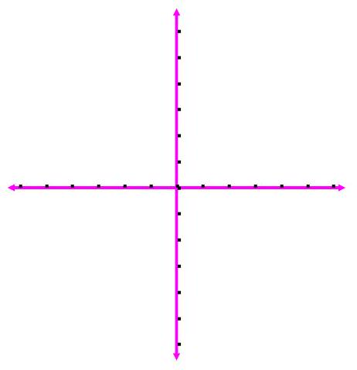
Plot this parametric curve with orientation.
$$\left\{\begin{matrix}x=2cos⁡t \\ y=1+3sin⁡t\end{matrix} 0≤t≤\frac{3π}{2}\right.$$
$$t$$ | $$x(t)$$ | $$y(t)$$ | $$(x(t),y(t))$$

