Math 1060 ~ Trigonometry

25 Parametric Descriptions for Oriented Curves

Eliminating the Parameter in Parametric Equations
To eliminate the parameter, we solve one equation for $t$ and use substitution to arrive at a single equation in terms of $x$ and $y$.

EX 1
Eliminate the parameter in this system of equations from the previous lecture.
$$\left\{\begin{matrix}x=2t+1 \\ y=t^{2}-2\end{matrix} t≥-2\right.$$
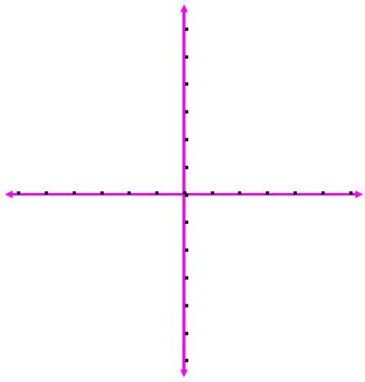

If the parametric equations have trigonometric expressions, using one of the Pythagorean Identities might be useful.

EX 2
Eliminate the parameter in this set of equations and sketch the curve.
$$\left\{\begin{matrix}x=2cos⁡t \\ y=1+3sin⁡t\end{matrix} 0≤t≤\frac{3π}{2}\right.$$
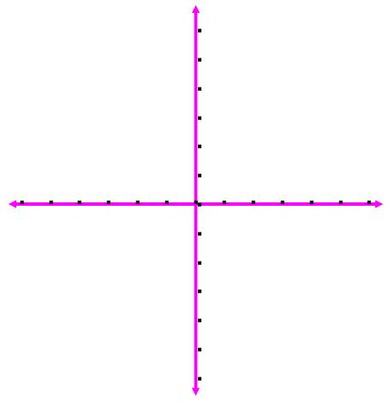

EX 3
Find a parameterization for each of these equations and sketch each one.

3a)
$3x-y^{2}=2$ from $x=-2$ to $x=3$

3b)
$x^{2}-2x+y^{2}+4y=4$

