Math 1060 ~ Trigonometry

26.5 Circles
A circle with center $(h,k)$ and radius $r>0$ is the set of all points $(x,y)$ in the plane whose distance to $(h,k)$ is $r$.
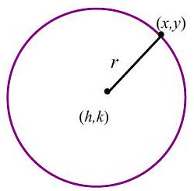
The Standard Equation of a Circle with center at $(h,k)$ and radius $r>0$ is
$(x-h)^{2}+(y-k)^{2}=r^{2}$.

EX 1
Write an equation of a circle with center at $(2,-1)$ and radius 5 .

EX 2
Find the center and radius of the circle given by the equation $(x+4)^{2}+(y+3)^{2}=9$. Graph the circle.
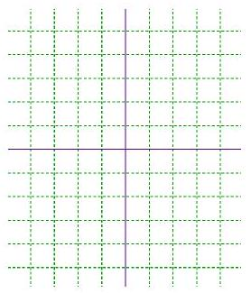

EX 3
Put this equation in standard form and graph the circle.
$$3x^{2}+3y^{2}+6x-12y-60=0$$
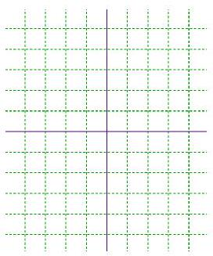

EX 4
Select the equations which might be a circle, put the equation in standard form and determine the center and radius.

4a)
$$x^{2}-y^{2}+3x-2y-6=0$$

4b)
$$x^{2}+6x-2y+6=0$$

4c)
$$2x^{2}+2y^{2}-4x-10=0$$

4d)
$$3x+2y-8=0$$

4e)
$x^{2}+y^{2}+9=0$

4f)
$$3x^{2}+2y^{2}+6x-12y-6=0$$

EX 5
Write an equation of a circle with the points $(-2,6)$ and $(3,-1)$ as endpoints of the diameter.
