Math 1060 ~ Trigonometry

3 The Unit Circle

The Unit Circle
Consider the Unit Circle, $x^{2}+y^{2}=1$, with angle $θ$ in standard position and the corresponding arc measuring $s$ units in length.
$$s=rθ$$
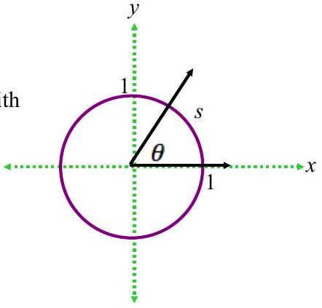

To identify real numbers with oriented angles, we "wrap" the real number line around the Unit Circle and associate to each real number $t$ an oriented arc on the unit circle with initial point $(1,0)$.
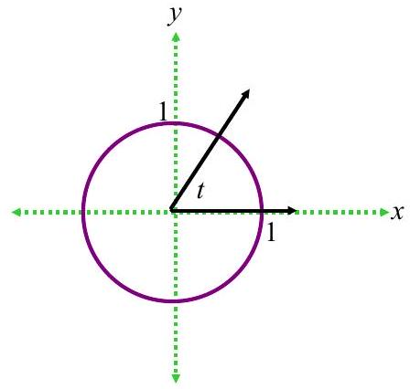

EX 1
Sketch the oriented arc on the Unit Circle corresponding to each of these real numbers.

1a)
$$t=\frac{3π}{4}$$
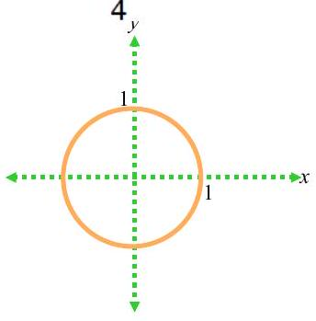

1b)
$$t=-3π$$

1c)
$$t=2$$

1d)
$$t=-\frac{π}{2}$$

Determining the cosine and sine functions as points on the Unit Circle.
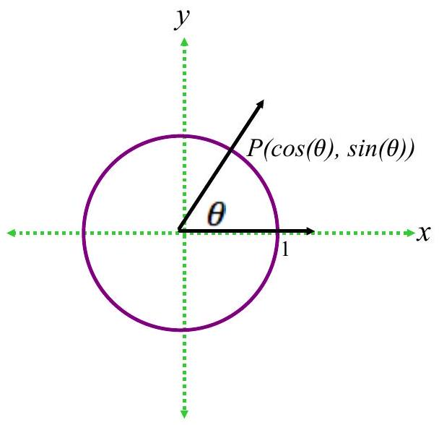

EX 2

2a)
Label the quadrant angles above in radians and degrees and determine the cosine and sine of each.

2b)
$$cos⁡(-π)=$$

Question: If the hypotenuse of an isosceles right triangle is 1 unit, how long are each of the legs?
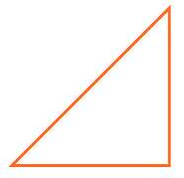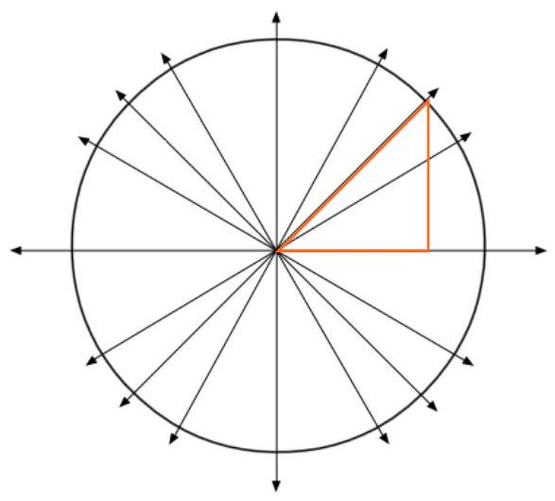

EX 3

3a)
On the figure above, label all the points on the Unit Circle corresponding with angles which are multiples of $\frac{π}{4}$.

3b)
$$sin⁡\frac{5π}{4}=$$

Question: If the hypotenuse of a right ${30}^{∘}-{60}^{∘}-{90}^{∘}$ triangle is 1 unit, how long are each of the legs?
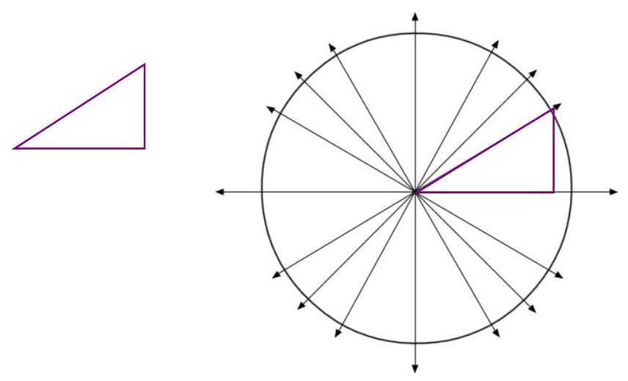

EX 4

4a)
On the figure above, label all the noints on the Unit Circle corresponding with angles which are multiples of $\frac{π}{6}$.

4b)
$$cos⁡\frac{5π}{6}=$$

4c)
$$sin⁡\frac{2π}{3}=$$

A complete Unit Circle looks like this.
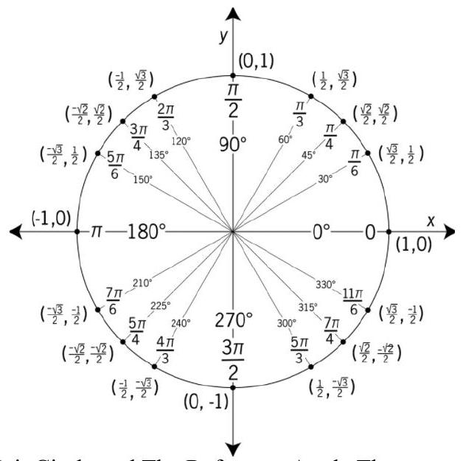
Given the symmetry of the Unit Circle and The Reference Angle Theorem, you can determine cosine and sine values of these common angles readily.

Reference Angle
A reference angle for a non-terminal angle, $θ$, is that angle made up of the terminal side of $θ$ and the $x$-axis.
- It is always positive.
- It is always acute.

Reference Angle Theorem: Suppose $α$ is the reference angle for $θ$. Then $cos⁡θ=±cos⁡α$ and $sin⁡θ=±sin⁡α$, where the sign is determined by the quadrant in which the terminal side of $θ$ lies.

EX 5
For each of the following angles, determine the reference angle and the sine and cosine of each.
Sine and Cosine Values of Common Angles
$θ$ degrees | $θ$ radians | $$Cos(θ)$$ | $$Sin(θ)$$
$$0^{∘}$$ | 0 | 1 | 0
$${30}^{∘}$$ | $$\frac{π}{6}$$ | $$\frac{\sqrt{3}}{2}$$ | $$\frac{1}{2}$$
$${45}^{∘}$$ | $$\frac{π}{4}$$ | $$\frac{\sqrt{2}}{2}$$ | $$\frac{\sqrt{2}}{2}$$
$${60}^{∘}$$ | $$\frac{π}{3}$$ | $$\frac{1}{2}$$ | $$\frac{\sqrt{3}}{2}$$
$${90}^{∘}$$ | $$\frac{π}{2}$$ | 0 | 1

5a)
$$\frac{2π}{3}$$

5b)
$-\frac{5π}{6}$

5c)
$${270}^{∘}$$

5d)
$$-{315}^{∘}$$

The Pythagorean Identity
For any angle, $θ,\cos^{2}⁡θ+\sin^{2}⁡θ=1$.

EX 6
Using the given information about $θ$, find the indicated value.

6a)
If $θ$ is a second quadrant angle, such that $sin⁡θ=\frac{3}{4}$, find $cos⁡θ$.

6b)
If $θ$ is between $π$ anc $\frac{3π}{2}$ and $cos⁡θ=\frac{1}{2}$, find $sin⁡θ$.

6c)
If $sin⁡θ=1$, find $cos⁡θ$.

