Math 1060 ~ Trigonometry

4 The Six Trigonometric Functions

The Trigonometric Functions
In addition to the sine and cosine functions, there are four more.
Trigonometric Functions: Suppose $θ$ is an angle plotted in standard position and $P(x,y)$ is the point on the terminal side of $θ$ which lies on the Unit Circle. The circular functions are defined as follows.
- The sine of $θ$, denoted $sin⁡(θ)$, is defined by $sin⁡(θ)=y$.
- The cosine of $θ$, denoted $cos⁡(θ)$, is defined by $cos⁡(θ)=x$.
- The tangent of $θ$, denoted $tan⁡(θ)$, is defined by $tan⁡(θ)=\frac{y}{x}$, provided $x≠0$.
- The cosecant of $θ$, denoted $csc⁡(θ)$, is defined by $csc⁡(θ)=\frac{1}{y}$, provided $y≠0$.
- The secant of $θ$, denoted $sec⁡(θ)$, is defined by $sec⁡(θ)=\frac{1}{x}$, provided $x≠0$.
- The cotangent of $θ$, denoted $cot⁡(θ)$, is defined by $cot⁡(θ)=\frac{x}{y}$, provided $y≠0$.

EX 1
Assume $θ$ is $\frac{π}{3}$ in this picture.
Find the six trigonometric functions of $θ$.
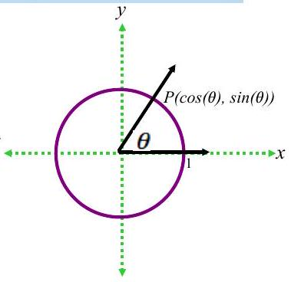

EX 2
Determine the tangent values for the first quadrant and each of the quadrant angles on this Unit Circle.
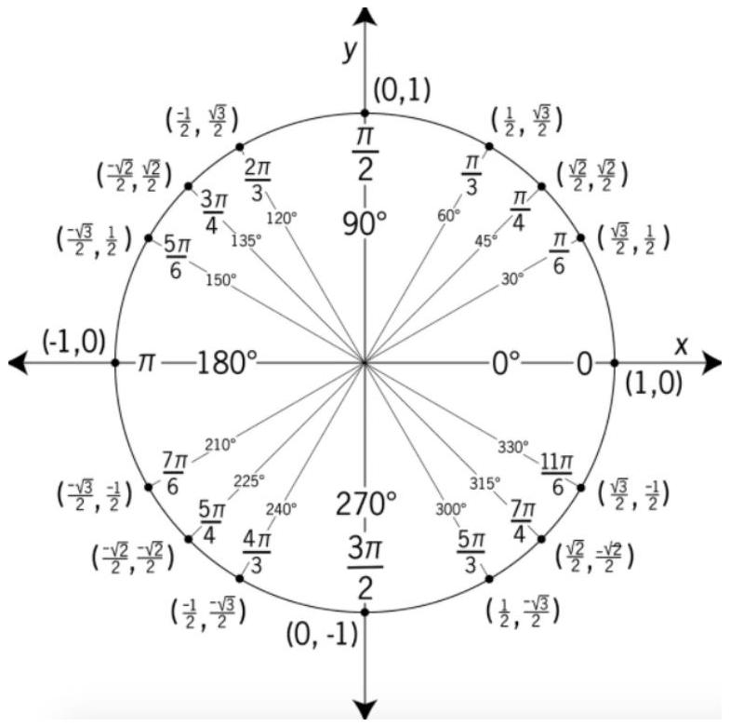

Reciprocal and Quotient Identities
- $tan⁡(θ)=\frac{y}{x}=\frac{sin⁡(θ)}{cos⁡(θ)}$, provided $cos⁡(θ)≠0$; if $cos⁡(θ)=0$ then $tan⁡(θ)$ is undefined.
- $cot⁡(θ)=\frac{x}{y}=\frac{cos⁡(θ)}{sin⁡(θ)}$, provided $sin⁡(θ)≠0$; if $sin⁡(θ)=0$ then $cot⁡(θ)$ is undefined.
- $sec⁡(θ)=\frac{1}{x}=\frac{1}{cos⁡(θ)}$, provided $cos⁡(θ)≠0$; if $cos⁡(θ)=0$ then $sec⁡(θ)$ is undefined.
- $csc⁡(θ)=\frac{1}{y}=\frac{1}{sin⁡(θ)}$, provided $sin⁡(θ)≠0$; if $sin⁡(θ)=0$ then $csc⁡(θ)$ is undefined.

EX 3
Find the indicated value, if it exists.

3a)
$$sec⁡{30}^{∘}$$

3b)
$$csc⁡\frac{11π}{6}$$

3c)
$$cot(2)$$

3d)
$tan⁡θ$, where $θ$ is any angle coterminal with ${270}^{∘}$.

3e)
$cos⁡θ$, where $csc⁡θ=-2$ and $\frac{3π}{2}<θ<2π$.

3f)
$sin⁡θ$, where $tan⁡θ=\sqrt{3}$ and $θ$ is in Q III.

Generalized Reference Angle Theorem
The values of the trigonometric functions of an angle, if they exist, are the same, up to a sign, as the corresponding trigonometric functions of the reference angle.
More specifically, if $α$ is the reference angle for $θ$, then $cos⁡θ=±cos⁡α$, $sin⁡θ=±sin⁡α$. The sign, + or - , is determined by the quadrant in which the terminal side of $θ$ lies.

EX 4
Determine the reference angle for each of these. Then state the cosine and sine and tangent of each.

4a)
$$-{225}^{∘}$$

4b)
$$\frac{11π}{6}$$

4c)
$$-\frac{3π}{4}$$

Finding Angles that Satisfy Cosine and Sine Equations

EX 5
Find all of the angles on the unit circle which satisfy the given equation.

5a)
$$sin⁡θ=0$$

5b)
$$cos⁡θ=-\frac{1}{2}$$

5c)
$$sin⁡θ=\frac{\sqrt{2}}{2}$$

Finding Angles that Satisfy Other Trigonometric Equations

EX 6
Find all of the angles on the unit circle which satisfy the given equation.

6a)
$$tan⁡θ=-1$$

6b)
$$sec⁡θ=2$$

6c)
$$cot⁡θ=0$$

