Math 1060 ~ Trigonometry

6 Beyond The Unit Circle

Determining Sine and Cosine
Consider the acute angle $θ$ drawn in standard position.
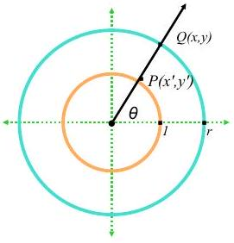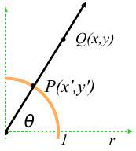
$Q(x,y)$ is a point on the terminal side of $θ$ which lies on the circle $x^{2}+y^{2}=r^{2}$.
$P\left(x^{'},y^{'}\right)$ is a point on the terminal side of $θ$ which lies on the Unit Circle.

Theorem
If $Q(x,y)$ is a point on the terminal side of an angle $θ$, plotted in standard position, which lies on the circle $x^{2}+v^{2}=r^{2}$, then
$x=rcos⁡θ$ and $y=rsin⁡θ$.
$$\begin{matrix} & cos⁡θ=\frac{x}{r}=\frac{x}{\sqrt{x^{2}+y^{2}}} \\ & sin⁡θ=\frac{y}{r}=\frac{y}{\sqrt{x^{2}+y^{2}}}\end{matrix}$$
From these it is possible to determine all of the other four functions.

EX 1
Determine the sine, secant and tangent of an angle which contains the point $Q(3,-2)$ when plotted in standard position.

EX 2
If the terminal side of $θ$ lies on the line $3x-4y=0$ in the third quadrant, find the values of the six trigonometric functions of $θ$ by finding a point on the line.

EX 3
Determine the radius of the circle of revolution for Salt Lake City, which is located at a latitude of ${40.76}^{∘}N$. Assume the radius at the equator to be 3960 miles.
