Math 1060 ~ Trigonometry

7 Graphing The Cosine and Sine Functions

$$f(x)=sin⁡x$$
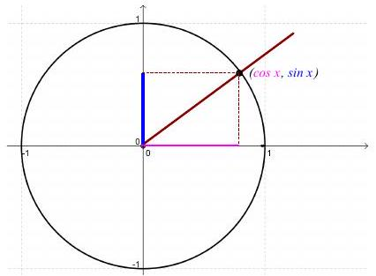

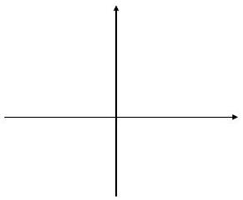

Graph of $f(x)=sin⁡x$
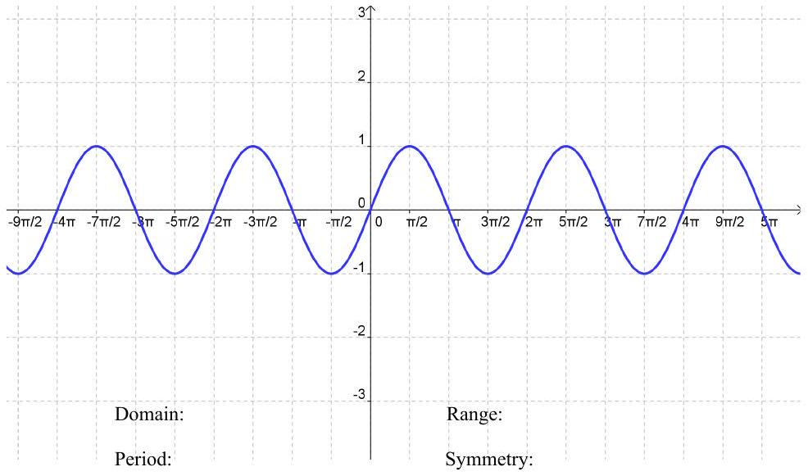

$$f(x)=cos⁡x$$
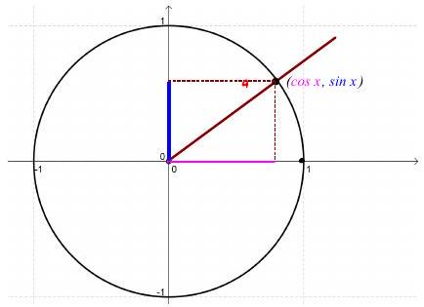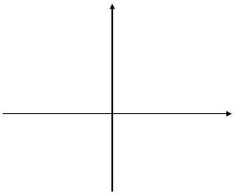
Graph of $f(x)=cos⁡x$
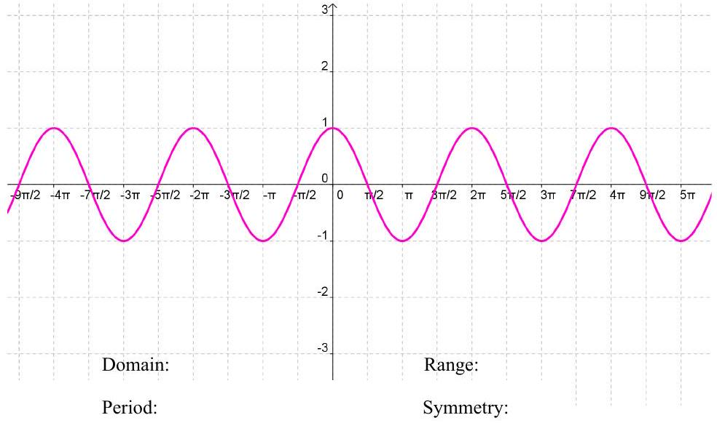

How can you graph $y=2sin⁡\left(x-\frac{π}{3}\right)+1$ ?
This is a transformation of the basic $y=sin⁡x$ curve.
It may help to remember transformations to one of the algebraic functions.
How does the graph of $y=-3(x+2)^{2}-1$ relate to the graph of $y=x^{2}$ ?
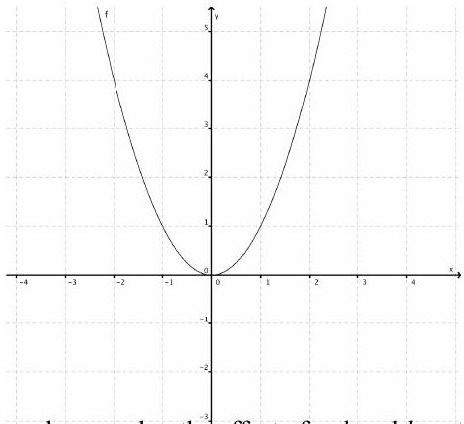
In general, remember the effect of $a,h$ and $k$ on the graph of $y=x^{2}$.
$$y=a(x-h)^{2}+k \\ y=Asin⁡(b(x-h))+k$$
What effect do $A,b,h$ and k have on the graph of trigonometric functions?
Let's look at it one part at a time: $y=Asin⁡x$
- Amplitude: $|A|$

EX 1
Graph each of these.
$$y=3sin⁡x$$
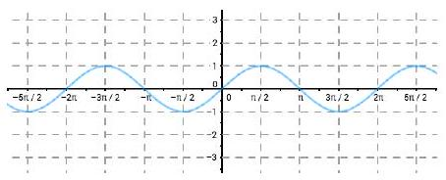

$$y=-2cos⁡x$$
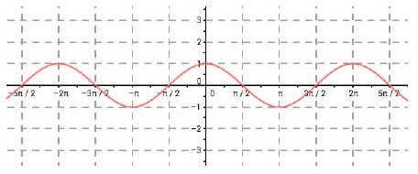

Periodic Functions
A function is periodic if there is a real number $p$ so that $f(x+p)=f(x)$. The smallest positive number $p$, if it exists is called the period of $f$.
$$y=sin⁡(bx)$$
- Period =

EX 2
Graph each of these.
$$y=sin⁡(2x)$$
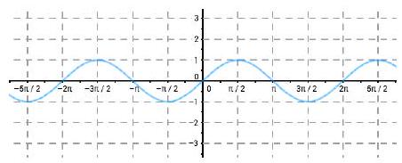

$$y=cos⁡\left(\frac{1}{2}x\right)$$
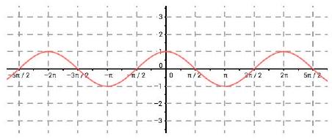

$$y=sin⁡(x-h)$$
- Horizontal shift (phase shift) =

EX 3
Graph each of these.
$$y=sin⁡(x+π)$$
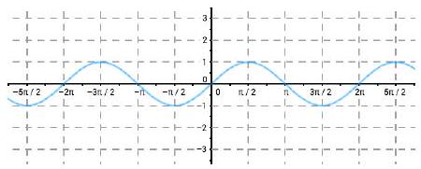

$$y=cos⁡\left(x-\frac{π}{2}\right)$$
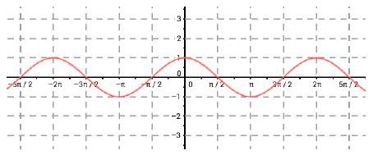

$$y=sin⁡(b(x-h))$$
- Period $=$
- Horizontal shift =

EX 4
Graph each of these.
$$y=sin⁡(2x-π)$$
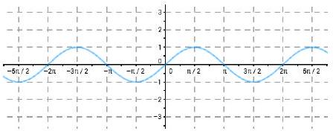

$$\left.y=cos⁡\left(\left(\frac{1}{2}\right)x+\frac{π}{2}\right)\right)$$
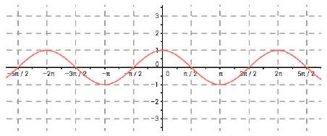

$$y=sin⁡(x)+k$$

Vertical Shift:

EX 5
Graph each of these.
$$y=\sin\left(x\right)-2$$
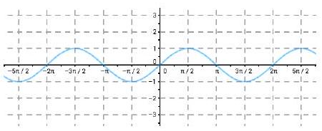

$$y=\cos\left(x\right)+1$$
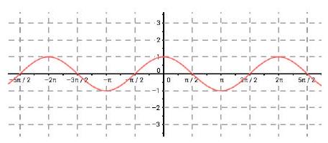

So, when we graph a sine or cosine function there are these things to consider:
- Amplitude
- Period
- Phase shift (horizontal)
- Vertical shift

EX 6
List the transformations of this function.
$$y=3cos⁡(2x-π)+1$$
- Amplitude
- Period
- Phase shift (horizontal)
- Vertical shift

EX 7
List the transformations of this function. $f(x)=-2sin⁡(4x-π)-2$.
- Amplitude
- Period
- Phase shift (horizontal)
- Vertical shift

EX 8
Analyze the transformations and write a function equation of this graph using the cosine function and then one using the sine function.
Period:
Amplitude:
Horizontal shift:
Vertical shift:
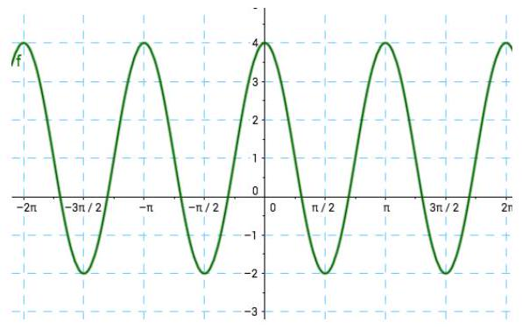

Here are some applets in case you want to play with the transformation variables.

www.analyzemath.com/trigonometry/sine.htm
http://tube.geogebra.org/student/m45354?mobile=true
Here are instructions and the equation format from the text for graphing a periodic (sinusoidal) function.
- For $ω>0$, the functions
- $C(x)=Acos⁡(ωx+ϕ)+B$ and $S(x)=Asin⁡(ωx+ϕ)+B$

  - have period $\frac{2π}{ω}$
  - have amplitude $|A|$
  - have phase shift $-\frac{ϕ}{ω}$
  - have vertical shift $B$

