Math 1060 ~ Trigonometry

9 Applications of Radian Measure

Vocabulary
Arc

Sector
Length of a circular arc

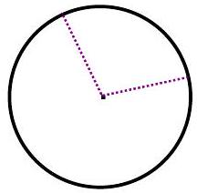

EX 1
Find the arc length along a circle of radius 10 cm subtended by an angle of ${125}^{∘}$.

EX 2
What is the radius of a circle for which $2/3$ of the circumference is $6π ft$?

Area of a Sector
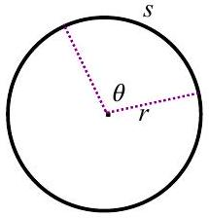

EX 3
A lawn sprinkler sprays a distance of 15 feet out and rotates back and forth at a ${120}^{∘}$ angle. What is the area that the sprinkler waters?

Linear and Angular Velocity
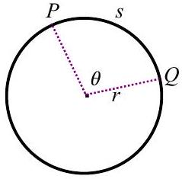
Velocity $=\overset{‾}{v}=\frac{ \text{displacement} }{ \text{time} }$

Average Angular Velocity $=\overset{‾}{ω}=\frac{ \text{change in angle} }{ \text{time} }$

Speed $=|\overset{‾}{v}|$

Velocity for Circular Motion
$$v=rω$$

EX 4
The giant wheel in London, known as the Millennium Wheel has a radius of 60 meters. It completes one rotation in 30 minutes. What is the linear and angular velocity of a person riding in one of the cabins on the wheel? (It does not stop to pick up passengers, they hop on and off as it moves.)

