Math 1210 #11
Derivatives of Trigonometric Functions

The derivative of $f(x)=sin⁡x$
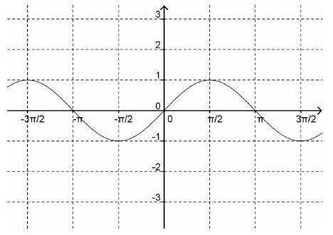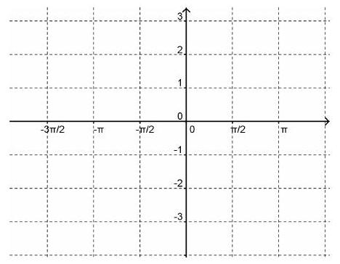

Use the definition of the derivative to find $D_{x}(sin⁡x)$.

The derivative of $f(x)=cos⁡x$
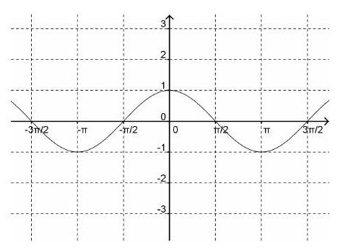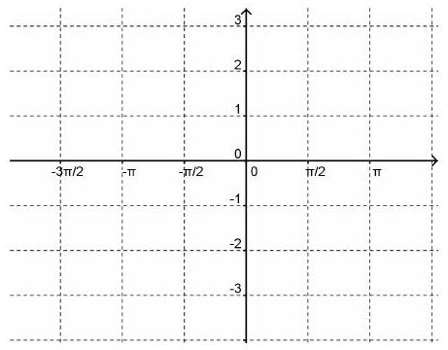

Here is a graph of $y=tan⁡x$ (black) and its derivative (green). Can you guess what it might be?
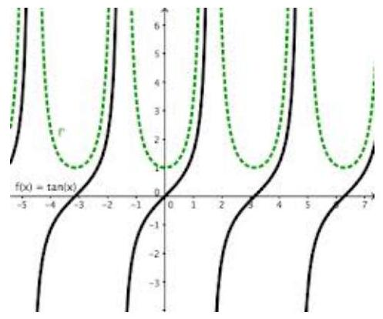

EX 1
Find $y^{'}$ for these functions.

1a)
$$y=\sin^{2}⁡x$$

1b)
$$y=cot⁡x$$

1c)
$$y=\frac{xcos⁡x+sin⁡x}{x^{2}+1}$$

1d)
$$y=\sin^{2}⁡x+\cos^{2}⁡x$$

EX 2
Find the equation of the tangent line to $y=cot⁡x$ at $x=π/4$

