Math 1210 #14
Implicit Derivatives
Given the equation $2y^{3}-y^{2}=x^{2}+5$
How do we find $\frac{dy}{dx}$?
Let's check to see if implicit differentiation is reasonable.
Differentiate $x^{2}+2x^{2}y+3xy=0$ in two ways.
Implicit

Explicit

EX 1
Find $\frac{dy}{dx}$ for the following equations.

1a)

$x\sqrt{y+1}=xy+1$

1b)
$9x^{2}+4y^{2}=36$
To convince ourselves that is works, let's look at a familiar equation.
Find the equation of the tangent line at the point $(-4,3)$ on this circle.
$$x^{2}+y^{2}=25$$
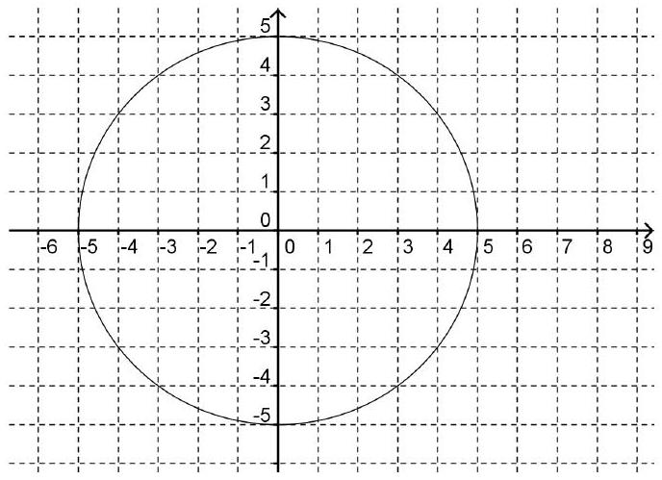
$$x^{2}+y^{2}=25$$

EX 2
Find the equation of the tangent line at the indicated point.
$$y+cos⁡\left(xy^{2}\right)+3x^{2}=4 \text{at} (1,0)$$
Power Rule (revisited): Basically the power rule can now be used with rational exponents.

EX 3
Find $y^{'}$ if $y=\sqrt[3]{x}-2x^{\frac{7}{2}}$

$$\begin{matrix} & \frac{x^{2}}{9}+\frac{y^{2}}{4}=2 \\ & \frac{1}{9}\frac{d}{dx}x^{2}+\frac{1}{4}\frac{d}{dx}y^{2}=\frac{d}{dx}2 \\ & \frac{1}{9}2x+\frac{1}{4}\frac{dy}{dx}2y=0 \\ & \frac{2y}{4}\frac{dy}{dx}=-\frac{2x}{9} \\ & \frac{dy}{dx}=\frac{-2x(4)}{9(2y)} \\ & \frac{dy}{dx}=\frac{-8x}{18y}=\frac{-4x}{9y}\end{matrix}$$

