Math 1210 #15
Related Rates

EX 1
The Ladder Problem
A $20-ft$ ladder is leaning against a wall. The bottom of the ladder is sliding out from the wall at the rate of 0.5 ft per sec.
How fast is the top of the ladder sliding down the wall?
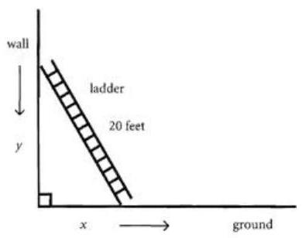

How fast is the top of the ladder sliding down the wall when the bottom is 12 ft. from the bottom of the wall?

EX 2
Assuming that a soap bubble retains its spherical shape as it expands, how fast is its radius increasing when the radius is 3 inches if air is being blown into it at the rate of 2 cubic inches per second?

EX 3
A child is flying a kite. If the kite is 90 ft above the child's hand level and the wind is blowing it on a horizontal course at $5ft/sec$, how fast is the child letting out the cord when 150 ft of cord is out? Assume that the cord remains straight from hand to kite.

EX 4
A student is using a straw to drink from a conical paper cup with a vertical axis. She drinks at a rate of $3{ cm}^{3}$ per second. If the height of the cup is 10 cm and the diameter of its opening is 6 cm , how fast is the level of the liquid in the cup falling when the depth of the liquid is 5 cm ?

We worked the first problem. Can you invent a scenario for the second?
