Math 1210 #16
Maxima and Minima
Maxima and Minima

Definition
Let $S$, the domain of $f$, contain the point $c$.
Then
- $f(c)$ is a maximum value of $f$ on $S$ if $f(c)≥f(x)$ for all $x$ in $S$.

- $f(c)$ is a minimum value of $f$ on $S$ if $f(c)≤f(x)$ for all $x$ in $S$.

- $f(c)$ is an extreme value of $f$ on $S$ if it is the maximum or a minimum value.

- the function we want to maximize or minimize is called the objective function.

Maximum - Minimum Existence Theorem
If $f$ is continuous on a closed interval $[a,b]$, then $f$ attains both a maximum and minimum value on that interval.
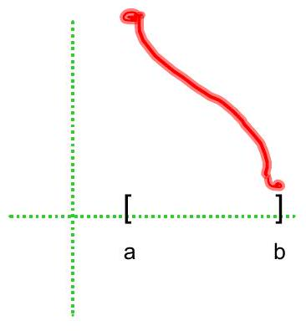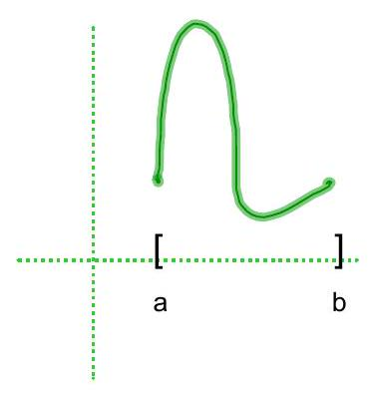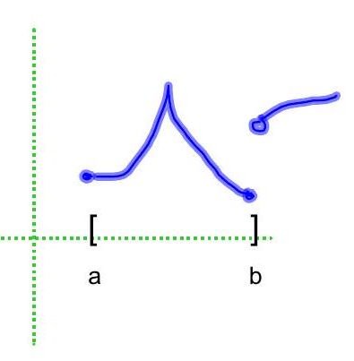

These can occur in one of three ways:
- endpoints of the closed interval.
- stationary points where $f^{'}(x)=0$.
- singular points where $f^{'}(x)$ does not exist.

Critical Point Theorem
Let $f$ be defined on a closed interval, $I$ containing the point $c$. If $f(c)$ is an extreme value, then $c$ is called a critical value.
($c,f(c)$ ) is either
- an endpoint of I or
- a stationary point of $f$, i.e., $f^{'}(c)=0$ or
- a singular point of $f$, i.e., $f^{'}(c)DNE$.

EX 1
Find the minimum and maximum values of $f(x)=-2x^{3}+3x^{2}$ on $[-1,3]$.

EX 2
Find the minimum and maximum points for $f(x)=x^{2/5}$ on $[-1,32]$

EX 3
Show that for a rectangle with perimeter of 30 inches, it has maximum area when it is a square.

EX 4
Identify critical points and specify the maximum and minimum values.
$$f(x)=x-2sin⁡x \text{on} [-2π,2π].$$

EX 5
Sketch the graph of a function with all of these characteristics:
- continuous, but not necessarily differentiable.
- has domain $[0,6]$
- reaches a maximum value of 4 (at $x=4$ )
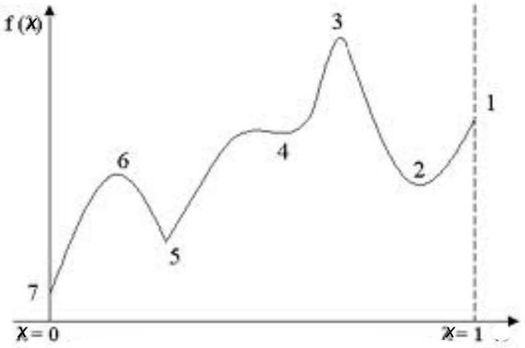

EX 6
Find all inflection points for $f(x)=2x^{\frac{1}{3}}-1$.

