Math 1210 #17
Monotonicity and Concavity

Definition
Let $f$ be defined on an interval I, (open, closed or neither), we say that:
- $f$ is increasing on I if for every $x_{1},x_{2}$ in I $x_{1}<x_{2}$ implies $f\left(x_{1}\right)<f\left(x_{2}\right)$.
- $f$ is decreasing on I if for every $x_{1},x_{2}$ in I $x_{1}<x_{2}$ implies $f\left(x_{1}\right)>f\left(x_{2}\right)$.
- $f$ is strictly monotonic on $I$ if it is either increasing or decreasing on $I$.

Monotonicity Theorem
Let $f$ be continuous on the interval, I and differentiable everywhere inside I.
- if $f^{'}(x)>0$ for all $x$ on the interval, then $f$ is increasing on that interval.
- if $f^{'}(x)<0$ for all $x$ on the interval, then $f$ is decreasing on that interval.

EX 1
For each function, determine where $f$ is increasing and decreasing.

1a)
$$f(x)=x^{3}+3x^{2}-12$$

1b)
$$f(x)=\frac{x-1}{x^{2}}$$

EX 2
Where is $f(x)=\cos^{2}⁡x$ increasing and decreasing on the interval $[0,2π]$ ?

Definition
Let $f$ be differentiable on an open interval, $I$.
$f$ is concave up on I if $f^{'}(x)$ is increasing on $I$, and
$f$ is concave down on $I$ if $f^{'}(x)$ is decreasing on $I$.
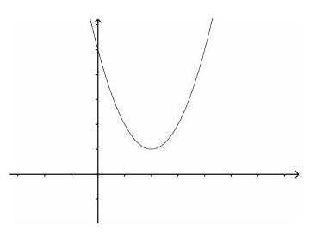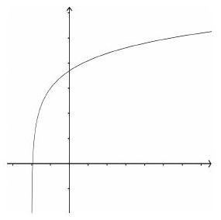

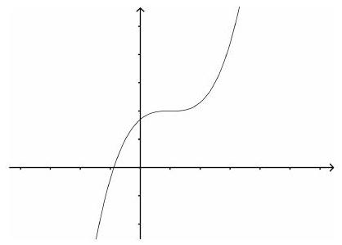

Concavity Theorem
Let $f$ be twice differentiable on an open interval, I.
If $f^{''}(x)>0$ for all $x$ on the interval, then $f$ is concave up on the interval.
If $f^{''}(x)<0$ for all $x$ on the interval, then $f$ is concave down on the interval.

EX 3
Determine where this function is increasing, decreasing, concave up and concave down.
$$f(x)=4x^{3}-3x^{2}-6x+12$$

Inflection Point
Let $f$ be continuous at $c$. We call ( $c,f(c)$ ) an inflection point of $f$ if $f$ is concave up on one side of $c$ and concave down on the other side of $c$.
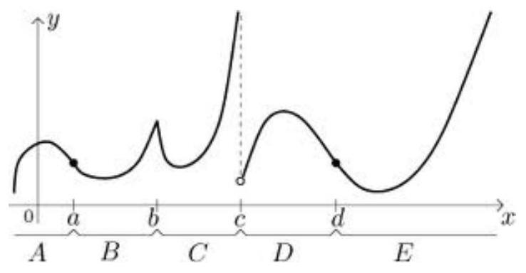

Inflection points will occur at $x$-values for which $f^{''}(x)=0$ or $f^{''}(x)$ is undefined.

EX 4
For this function, determine where it is increasing and decreasing, where it is concave up and down, find all max/min and inflection points. Use this information to sketch the graph.
$$f(x)=8x^{1/3}-x^{4/3}$$
