Math 1210 #18
Local Extrema

Definition
Let $S$ be the domain of $f$ such that $c$ is an element of $S$.
Then,
- $f(c)$ is a local maximum value of $f$ if there exists an interval $(a,b)$ containing $c$ such that $f(c)$ is the maximum value of $f$ on $(a,b)∩S$.
- $f(c)$ is a local minimum value of $f$ if there exists an interval ( $a,b$ ) containing $c$ such that $f(c)$ is the minimum value of $f$ on $(a,b)∩S$.
- $f(c)$ is a local extreme value of $f$ if it is either a local maximum or local minimum value.
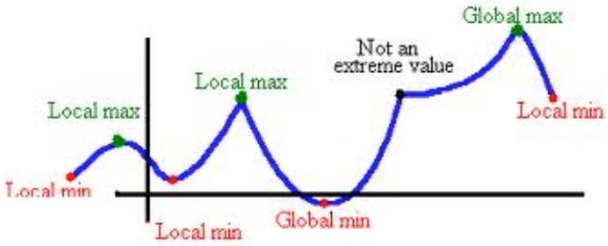
How do we find the local extrema?

First Derivative Test
Let $f$ be continuous on an open interval $(a,b)$ that contains a critical $x$-value.
- If $f^{'}(x)>0$ for all $x$ on ( $a,c$ ) and $f^{'}(x)<0$ for all $x$ on ( $c,b$ ), then $f(c)$ is a local maximum value.
- If $f^{'}(x)<0$ for all $x$ on $(a,c)$ and $f^{'}(x)>0$ for all $x$ on $(c,b)$, then $f(c)$ is a local maximum value.
- If $f^{'}(x)$ has the same sign on both sides of $c$, then $f(c)$ not a maximum nor a minimum value.
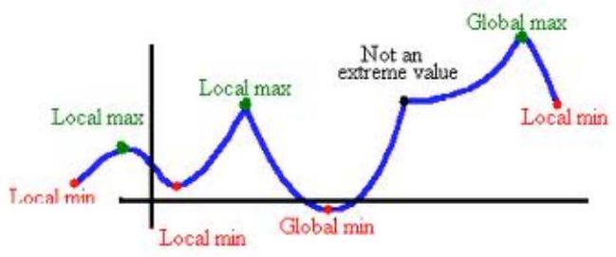

EX 1
Determine local maximum and minimum points for $y=2x^{2}-5x+3$.

EX 2
Find all local maximum and minimum points for $f(x)=\frac{1}{2}x+sin⁡x$ on $[0,2π]$.

Theorem: Second Derivative Test
Let $f^{'}$ and $f^{''}$ exist at every point on the interval $(a,b)$ containing $c$ and $f^{'}(c)=0$.
- If $f^{''}(c)<0$, then $f(c)$ is a local maximum.
- If $f^{''}(c)>0$, the $f(c)$ is a local minimum.

EX 3
Find all critical points for $f(x)=x^{3}-3x^{2}+1$.

EX 4
Find local and global extrema for $y=x^{2}+\frac{1}{x^{2}}$ on $[-2,2]$.

EX 5
Let $f$ be continuous such that $f^{'}$ has the following graph.
Try to sketch a graph of $f(x)$ and answer these questions.
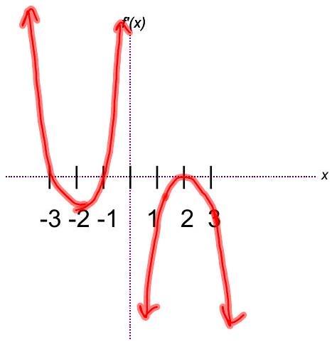

5a)
Where is $f$ increasing?

5b)
Where is f decreasing?

5c)
Where is $f$ concave up?

5d)
Where is $f$ concave down?

5e)
Where are inflections points?

5f)
Where are local max/min values?
