Math 1210 #19
Sketching a function

EX 1
Sketch the graph of $f(x)=x^{2}\left(x^{2}-1\right)$.

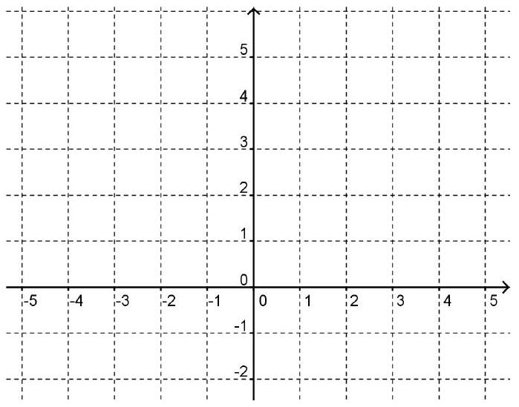
1a)
domain

1b)
symmetry

1c)
x-intercepts

1d)
First derivative information

1e)
Second derivative information

1f)
Asymptotes:

EX 2
Sketch the graph of $f(x)=\frac{(x-3)^{2}}{x}$.
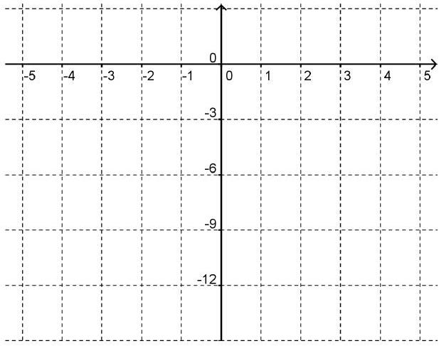

EX 3
Sketch the graph of $f(x)=|x|^{3}$
