Math 1210 #1
Calculus: The Slope of a Line

There is only one line between any 2 points.
The slope of a line is:
The steepness of the line.
The vertical change over the horizontal change, denoted by $m$.
Given two points, $\left(x_{1},y_{1}\right),\left(x_{2},y_{2}\right)$ in the Cartesian Plane,
$$m=$$
Examples of slope:
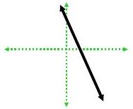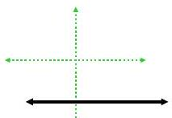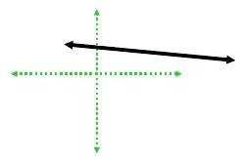
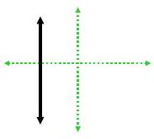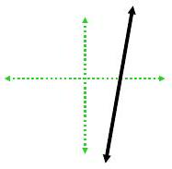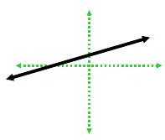

EX 1

1a)
Find the slope of the line containing these points: $(-3,2)$ and $(2,5)$

1b)
Find the slope of the line containing these points: (5, -6) and (-2,-6)

Point-Slope Form of a Line
Given that $m=$ the slope of a line and it goes through the point $\left(x_{1},y_{1}\right)$, then we know:

Slope-Intercept Form of a Line
Given that the slope of a line is $m$ and the y -intercept is the point $(0,b)$, then the equation of the line is:

EX 2

2a)
Find the equation of the line going through $(-4,1)$ and $(5,2)$.

2b)
Find the equation of the line with slope, $m=3$ and y -intercept $(0,5)$.

General Equation of a Line
Every line can be written in the form $Ax+By+C=0$, where $A,B$, and $C$ are integers.

EX 3
Write the equations from Exercise 2 in general form.

Parallel and Perpendicular Lines
Parallel lines have the same slope.
Perpendicular lines have negative reciprocal slopes.
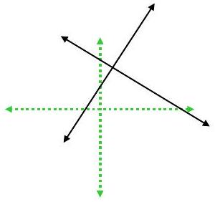

EX 4

4a)
Find the equation of the line parallel to $3x-4y=8$ which passes through the point $(1,3)$.

4b)
Find the equation of the line perpendicular to $y=-3x+5$ which passes through the origin.

Determine the slope of each line segment in this function.
