Math 1210 #2
Rigorous Study of Limits

Definition
To say that $\lim_{x→c} f(x)=L$ means that for every $ε>0$ (no matter how small), there exists a corresponding $δ>0$ such that $|f(x)-L|<ε$ provided that $0<|x-c|<δ$;
that is, $0<|x-c|<δ⇒|f(x)-L|<ε$
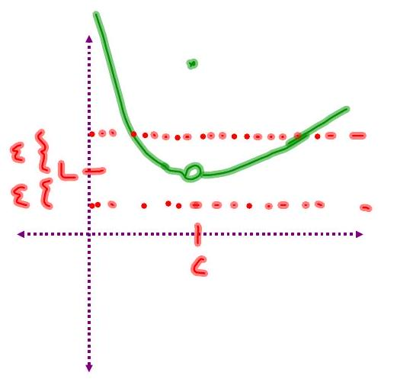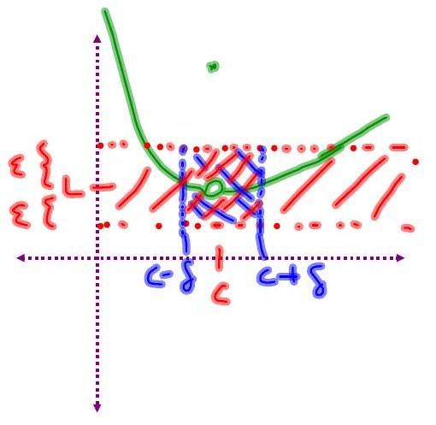

EX 1
Prove that $\lim_{x→3} (2x-5)=1$.

EX 2
Prove that $\lim_{x→1} \frac{2(x-1)(x+3)}{x-1}=8$

EX 3
Prove that $\lim_{x→c} \frac{1}{x-5}=\frac{1}{c-5}$ for all $c≠5$
