Math 1210 #21
Solving Equations Numerically
Three numeric methods for solving an equation numerically:
- Bisection Method
- Newton's Method
- Fixed-point Method

Bisection Method Algorithm
Let $f\left(x\right)$ be a continuous function and let $a_{1}$ and $b_{1}$ be numbers satisfying $a_{1}<b_{1}$ and $f\left(a_{1}\right)⋅f\left(b_{1}\right)<0$.
Let E denote the desired bound for the error $\left|r-m_{n}\right|$.
Pros:
Cons:
Repeat steps 1 to 5 for $n = 1, 2, …$ until $h_{n}<E$.
- Calculate $m_{n}=\frac{\left(a_{n}+b_{n}\right)}{2}$.
- Calculate f$\left(m_{n}\right)$ and if f$\left(m_{n}\right)=0$ then STOP.
- Calculate $h_{n}=\left|\frac{b_{n}-a_{n}}{2}\right|$ (for error testing).
- If $f\left(a_{n}\right)⋅f\left(m_{n}\right)<0$, then set $a_{n+1}=a_{n}$ and $b_{n+1}=m_{n}$.
- If $f\left(a_{n}\right)⋅f\left(m_{n}\right)>0$, then set $a_{n+1}=m_{n}$ and $b_{n+1}=b_{n}$.

EX 1
Approximate the real root to 2 decimal places. f(x)=x4+5x3+1 on [-1,0]

Newton's Method Algorithm
Let $f\left(x\right)$be a differentiable function and let $x_{1}$ be an initial approximation to the root, $r$, of $f\left(x\right)=0$. Let E denote a bound for the error $\left|r-x_{n}\right|$.
Repeat the following step for $n = 1, 2, …$ until $\left|x_{n+1}-x_{n}\right|<E$.
$$x_{n+1} = x_{n} - \frac{f\left(x_{n}\right)}{f'\left(x_{n}\right)}$$
Pros:
Cons:
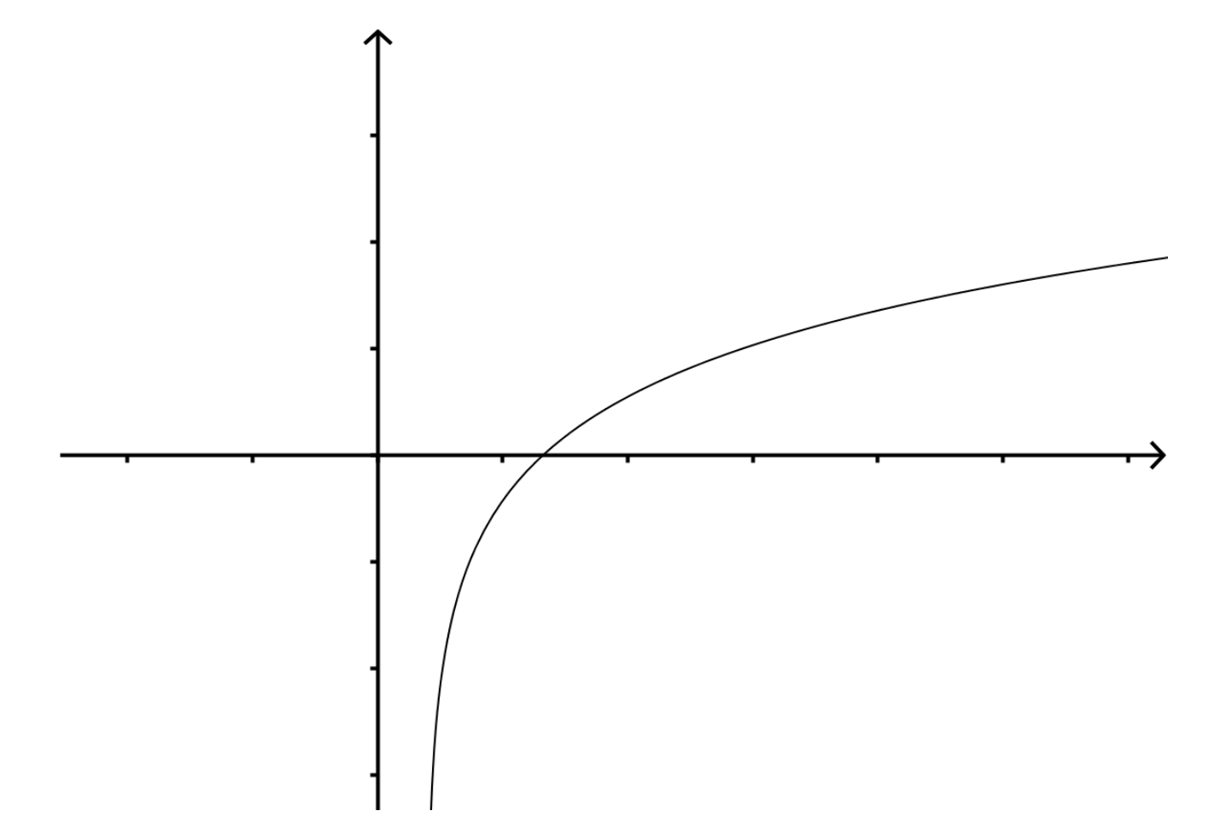

EX 2
Use Newton's method to approximate a root of $7x^{3}+2x-5=0$ to 5 decimal places.

Warning on Newton's Method:
