Math 1210 #2
Introduction to Area

Area of a Polygon:
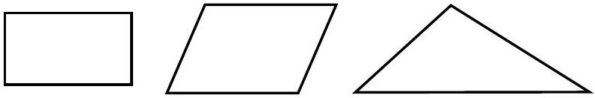

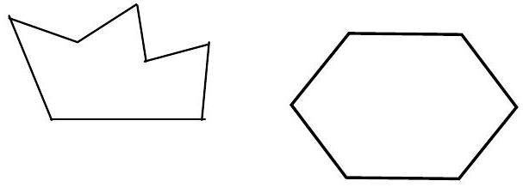

Estimating the area of a circle:
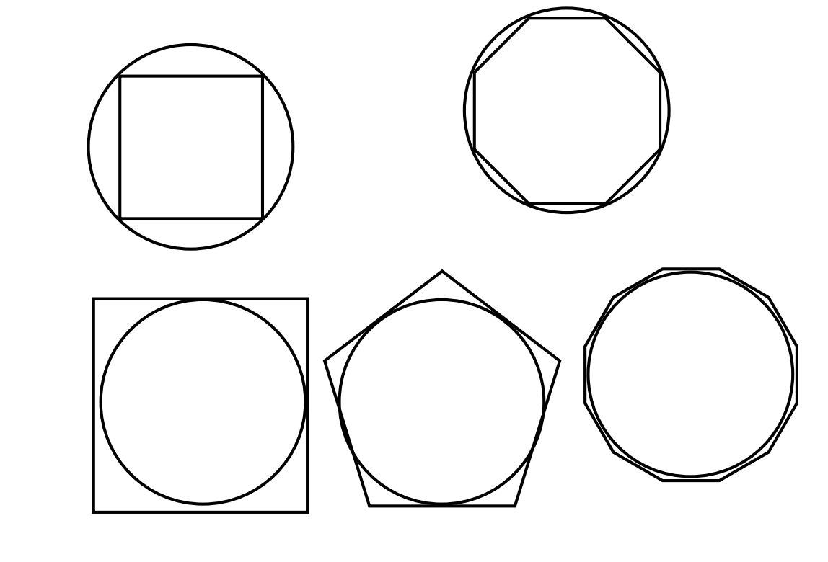

Sums and Sigma Notation
$$1+2+3+4+…+100=$$
$$2+4+6+8+…+1000=$$
$$1+4+9+16+…+625=$$
$\sum{}=$ Sigma, the capitol Greek letter called "sigma";
It means summation. $i=$ index
$$\sum_{j=1}^{n}{\frac{1}{j}}=$$
$$\sum_{i=1}^{n}{c}=$$

Linearity of $Σ$

Let $\left\{a_{i}\right\}$ and $\left\{b_{i}\right\}$ denote two sequences and $c$ is a real number.
- $\sum_{i=1}^{n}{c}a_{i}=c\sum_{i=1}^{n}{a_{i}}$
- $\sum_{i=1}^{n}{a_{i}}±b_{i}=\sum_{i=1}^{n}{a_{i}}±\sum_{i=1}^{n}{b_{i}}$

Special Sum Formulas

$$\begin{matrix} & \sum_{i=1}^{n}{ } i=1+2+3+…+n=\frac{n\left(n+1\right)}{2} \\ & \sum_{i=1}^{n}{ } i^{2}=1^{2}+2^{2}+3^{2}+…+n^{2}=\frac{n\left(n+1\right)\left(2n+1\right)}{6} \\ & \sum_{i=1}^{n}{ } i^{3}=1^{3}+2^{3}+3^{3}+…+n^{3}={\left[\frac{n\left(n+1\right)}{2}\right]}^{2} \\ & \sum_{i=1}^{n}{ } i^{4}=1^{4}+2^{4}+3^{4}+…+n^{4}=\frac{n\left(n+1\right)\left(6n^{3}+9n^{2}+n-1\right)}{30}\end{matrix}$$

EX 1
$$\sum_{i=1}^{10}{\left[\left(i-1\right)\left(4i+3\right)\right]}$$

EX 2
$$\sum_{j=1}^{n}{{\left(2j-3\right)}^{2}}$$

EX 5
Change the variable in the index to start at 1.
$$\sum_{k=5}^{14}{ }k2^{k-4}$$

Collapsing Sum
$$\sum_{i=1}^{n}{\left(a_{i+1}-a_{i}\right)}=a_{n+1}-a_{1}$$

EX 3
$$\sum_{k=1}^{10}{\left(2^{k}-2^{k-1}\right)}$$

EX 4
$$\sum_{k=3}^{m+1}{\left(a_{k}-a_{k-1}\right)}$$

We will estimate the area under a curve using inscribed or circumscribed rectangles.
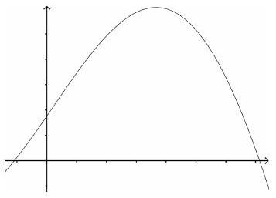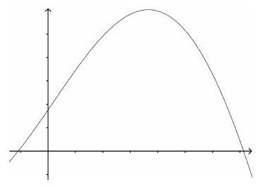

EX 6
For $f\left(x\right)=3x-1$, divide the interval $\left[1,3\right]$ into 4 equal subintervals.
Calculate the area of the circumscribed rectangles.
