Math 1210 #25
The Definite Integral
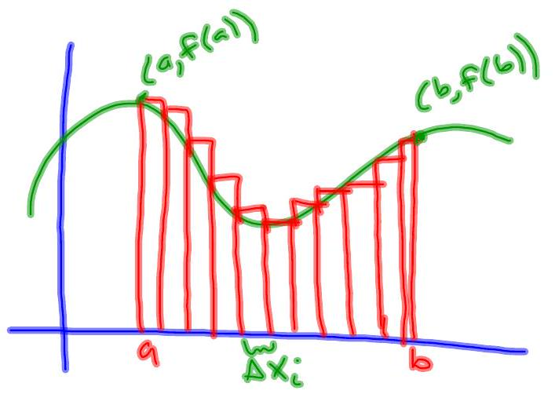

Definition of the Definite Integral
Let $f$ be a function that is defined on $[a,b]$. If $\lim_{|P|→0} ∑_{i=1}^{n} f\left(\overline{x_{i}}\right)Δx_{i}$ exists,
we say $f$ is integrable on $[a,b]$ and
$$∫_{a}^{b} f(x)dx=\lim_{|P|→0} ∑_{i=1}^{n} f\left(\overline{x_{i}}\right)Δx_{i}$$
$$\begin{matrix} & \int_{a}^{b}{ } f(x)dx=A_{up}-A_{down} \\ & \int_{a}^{a}{ } f(x)dx=0 \\ & \int_{a}^{b}{ } f(x)dx=-\int_{b}^{a}{ } f(x)dx\end{matrix}$$
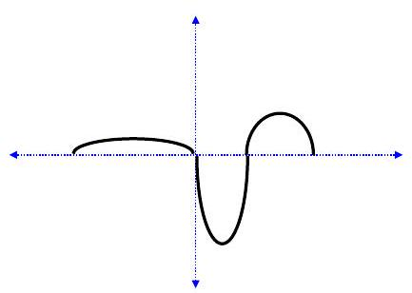

Integrability Theorem
If $f$ is bounded on $[a,b]$ and continuous there except for a finite number of discontinuities, then $f$ is integrable on $[a,b]$. So, if $f$ is continuous on $[a,b]$ it is integrable on $[a, b]$.

Interval Additive Property
If $f(x)$ is integrable, then $\int_{a}^{c}{ }f(x)dx=\int_{a}^{b}{ }f(x)dx+\int_{b}^{c}{ }f(x)dx$.

EX 1
Evaluate this definite integral using the definition.
$$\int_{-1}^{2}{ }(2x-3)dx$$

EX 2
Evaluate this definite integral using the definition.
$$\int_{0}^{2}{ }\left(3x^{2}+2\right)dx$$

EX 3
Find the area of the region under the curve of $f(x)=-x^{2}+1$ on the interval $[-1,1]$.
(To do this, divide the interval $[-1,1]$ into $n$ equal subintervals, calculate the area of the circumscribed or inscribed rectangles and take the limit as $n→∞$.)

