Math 1210 #26
The First Fundamental Theorem of Calculus

The First Fundamental Theorem of Calculus
Let $f$ be continuous on $[a,b]$ and let $x$ be a value in $(a,b)$. Then

$$\frac{d}{dx}\int_{a}^{x}{ }f(t)dt=f(x)$$

Theorem: Comparison Property
If $f$ and $g$ are integrable on $[a,b]$ and if $f(x)≤g(x)$ for all $x$ on $[a,b]$, then
$\int_{a}^{b}{ }f(x)dx≤\int_{a}^{b}{ }g(x)dx$
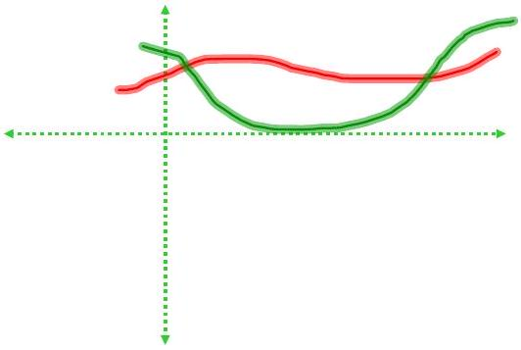

Theorem: Boundless Property
If f is integrable on $[a,b]$ and $m≤f(x)≤M$ for all a on $[a,b]$,
then $m(b-a)≤\int_{a}^{b}{ }f(x)dx≤M(b-a)$

Theorem: Linearity of the Definite Integral

If $f$ and $g$ are integrable on $[a,b]$ and $k$ is a real number, then
- $\int_{a}^{b}{ }kf(x)dx=k\int_{a}^{b}{ }f(x)dx$
and
- $\int_{a}^{b}{ }(f(x)±g(x))dx=\int_{a}^{b}{ }f(x)dx±\int_{a}^{b}{ }g(x)dx$

EX 1
Suppose
$$\int_{0}^{1}{ }f(x)dx=2 \int_{1}^{2}{ }f(x)dx=3$$

$$\int_{0}^{1}{ }g(x)dx=-1 \int_{0}^{2}{ }g(x)dx=4$$
Calculate $\int_{0}^{2}{ }(\sqrt{3}f(t)+\sqrt{2}g(t)+π)dt$.

EX 2
Find $G^{'}(x)$ for each of these.

2a)
$G(x)=\int_{3}^{x}{ }4tdt$

2b)
$G(x)=\int_{1}^{x}{ }\left(\cos^{3}⁡(2t)tan⁡(t)\right)dt -π/2<x<π/2$

2c)
$G(x)=\int_{-2}^{x}{ }(xt)dt$

EX 3
Find $\frac{d}{dx}\int_{1}^{x^{2}+x}{ }\sqrt{2w+sin⁡w}dw$

$$\frac{d}{dx}\int_{a}^{x}{ }f(t)dt=f(x)$$

