Math 1210 #29
Area of a Plane Region
$A=$ The area between a curve, $f(x)$, and the $x$-axis from $x=a$ to $x=b$ is found by
$$\int_{a}^{b}{ }f(x)dx$$

EX 1
Find the area of the region between the function and the $x$-axis on the $x$-interval $[-1,2]. f(x)=x^{3}-x+2$
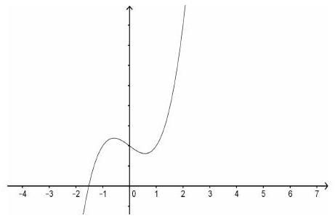

EX 2
Find the area between $y=\sqrt{x}-10$ and $y=0$ between $x=0$ and $x=9$.
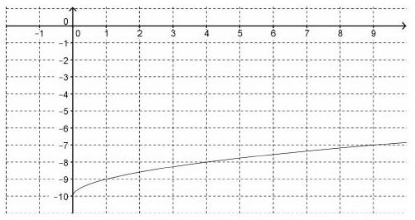

EX 3
Find the area between these two curves.
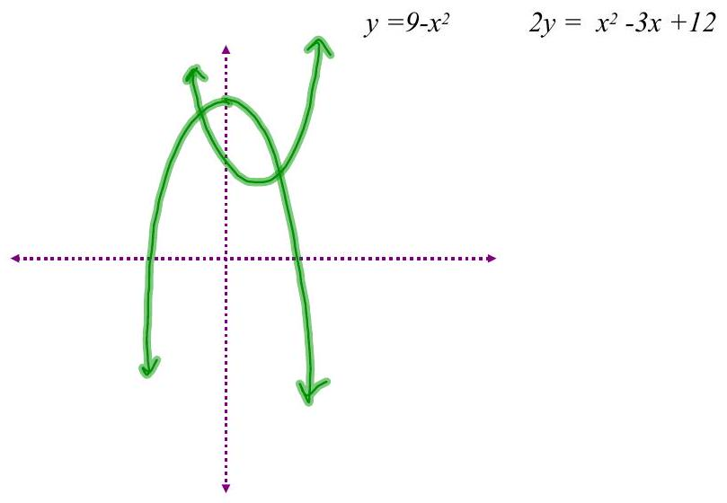

EX 4
Find the area of the region bounded by these two curves.
$x=y^{2}-2y$ $x-y-4=0$

