Math 1210 #2
Limits: An Introduction
Consider this function: $f\left(x\right)=\frac{x^{2}+x-12}{x-3}$
What happens at $x=3$ ?
What happens as we approach $x=3$ ?
$$x$$ | $$f\left(x\right)$$
3.25 | 7.25
3.2 | 7.2
3.1 | 7.05
3.05 | 7.01
3.001 | 7.001
3 | $$?$$
2.00 | 6.99
2.95 | 6.95
2.9 | 6.9
2.8 | 6.8

So we say as x approaches $3,f\left(x\right)$ approaches 7.
Algebraically we compute it this way: Graphically, it looks like this:
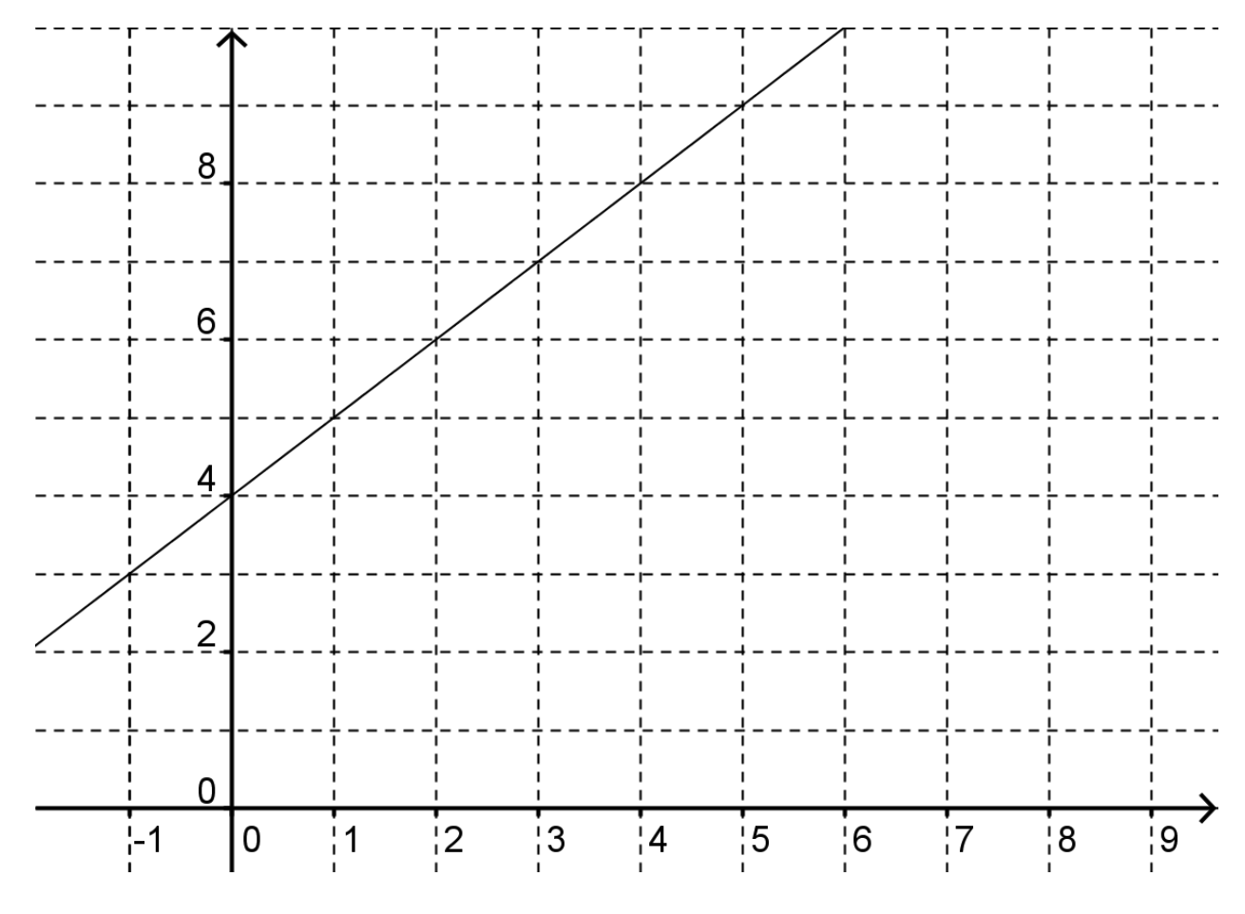

Definition
To say $\lim_{x→c} f\left(x\right)=L$ means that when $x$ is near, but different from $c$, then $f\left(x\right)$ is near $L$.

EX 1

$$\lim_{x→2} \left(3x+1\right)=$$

EX 2

$$\lim_{x→5} \frac{2x^{2}-7x-15}{x-5}=$$

EX 3

$$\lim_{x→9} \frac{x-9}{\sqrt{x}-3}=$$

EX 4
$$\lim_{x→0} \frac{sin{x}}{x}=$$
Argument 1 | Argument 2
1.0 | 0.84147
0.5 | 0.95885
0.1 | 0.99833
0.01 | 0.99998
0 | $$?$$
-0.01 | 0.99998
-0.1 | 0.00933
-0.5 | 0.05885
-1.0 | 0.84147

Graphically:
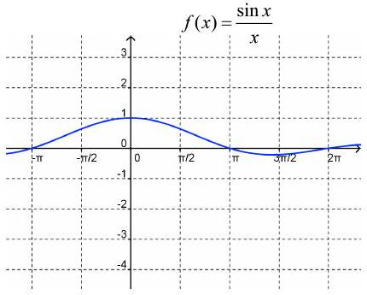

EX 5
$$\lim_{x→0} sin\left(\frac{1}{x}\right)=$$
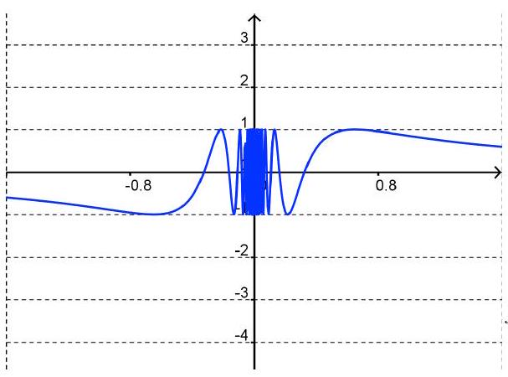

EX 6
$$\lim_{x→3} \left[\left[x\right]\right]=$$

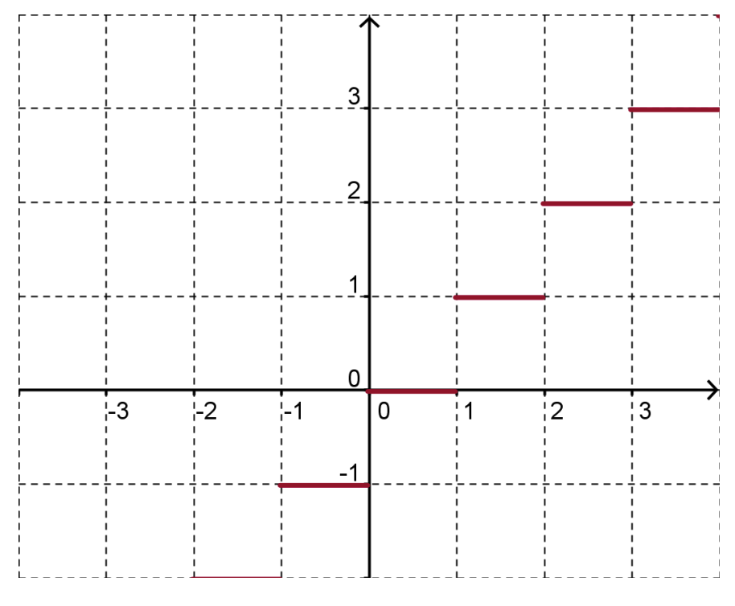

Definition: Right and Left Hand Limits
$\lim_{x→c^{+}} f\left(x\right)=L$ means that when x approaches $c$ from the right side of $c$, then $f\left(x\right)$ is near $L$.
$\lim_{x→c^{-}} f\left(x\right)=L$ means that when x approaches $c$ from the left side of $c$, then $f\left(x\right)$ is near $L$.

Theorem A
$\lim_{x→c}{f\left(x\right)}=L$ iff $lim_{x→c^{-}}f\left(x\right)=L=lim_{x→c^{+}}f\left(x\right)$

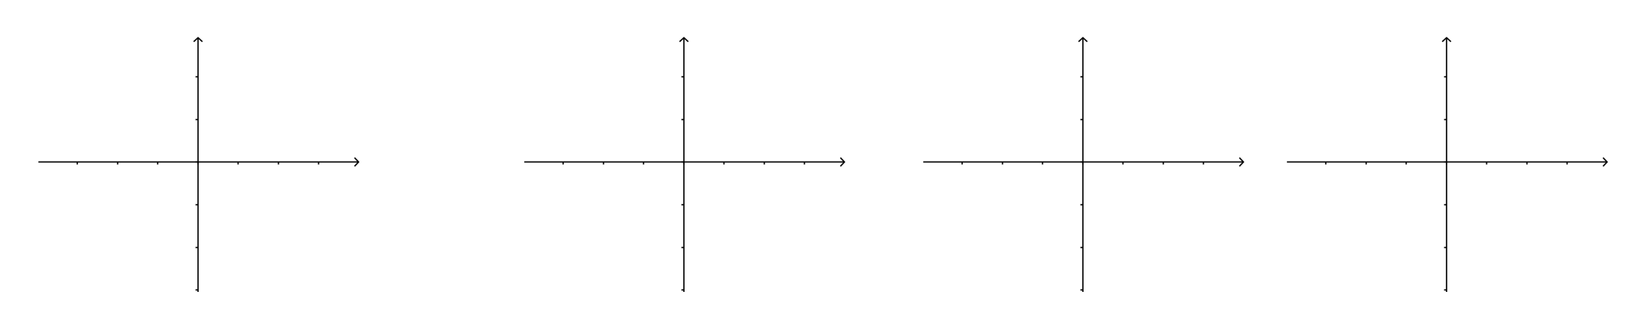

Determine these limits for this function

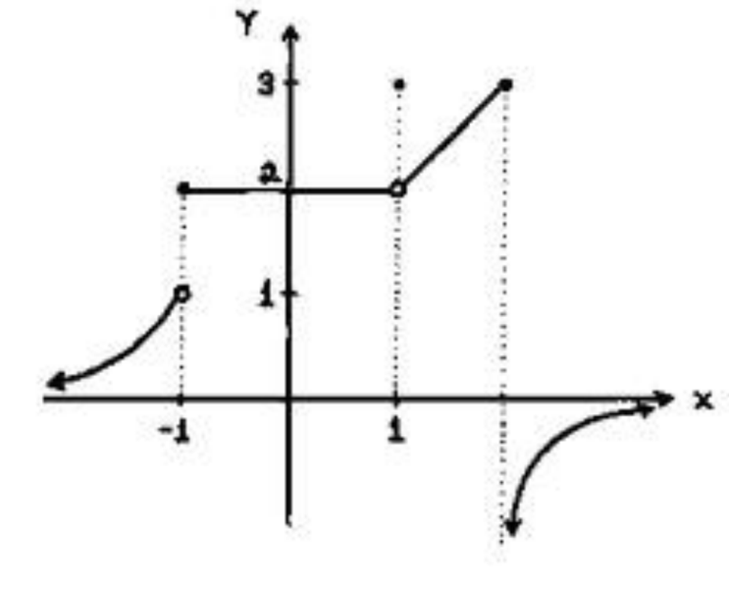
$\lim_{x→-1} f\left(x\right)=$

$$\lim_{x→-1^{-}} f\left(x\right)=$$

$$\lim_{x→-1^{+}} f\left(x\right)=$$

$$\lim_{x→1} f\left(x\right)=$$

$$\lim_{x→0} f\left(x\right)=$$

