Math 1210 #30
Volume of Solids

The volume of a solid right prism or cylinder is the area of the base times the height.
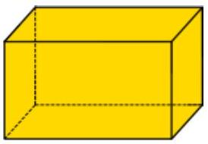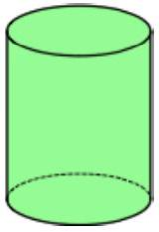

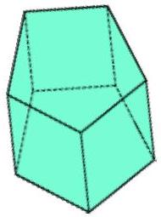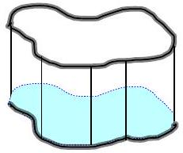

Volume of one penny:

Volume of a stack of pennies:

Disk Method
How would we find the volume of a shape like this?
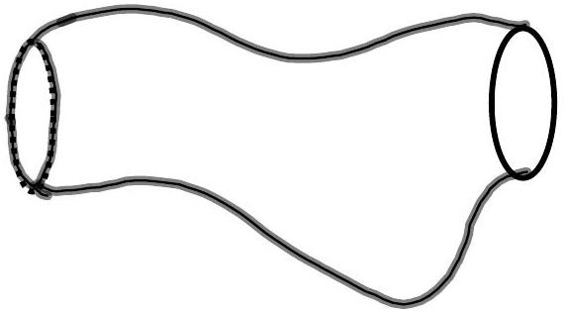

EX 1
Find the volume of the solid of revolution obtained by revolving the region bounded by $y=\sqrt{x}$, the $x$-axis and the line $x=9$ about the $x$-axis.
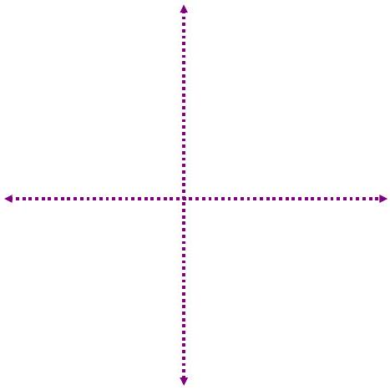

EX 2
Find the volume of the solid generated by revolving the region enclosed by $x=\frac{2}{y},y=2,y=6$, and $x=0$ about the $y$-axis.

Washer Method
How would we find the volume of a washer?
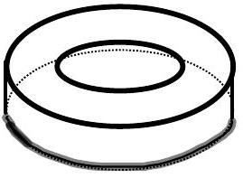

EX 3
Find the volume of the solid generated by revolving about the $x$-axis the region bounded by $y=6x$ and $y=6x^{2}$.
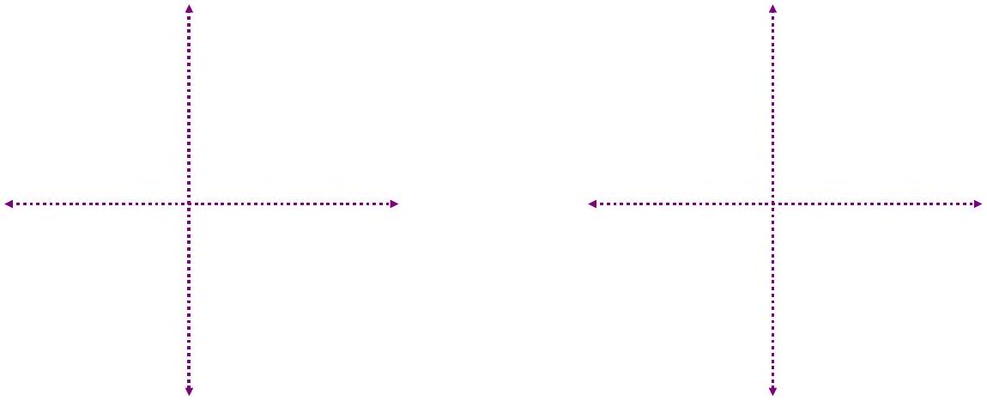

EX 4
Find the volume of the solid generated by revolving about the line $y=2$ the region in the first quadrant bounded by these parabolas and the y -axis. (Hint: Always measure radius from the axis of revolution.)
$$\begin{matrix}3x^{2}-16y+48=0 \\ x^{2}-16y+80=0\end{matrix}$$

Shell Method
How would we find the volume of a label we peel off a can?
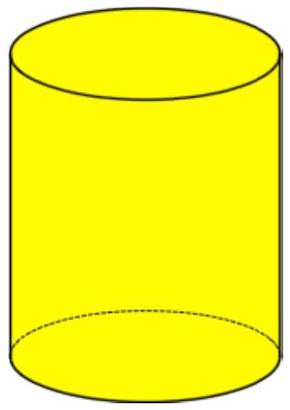

EX 5
Find the volume of the solid generated when the region bounded by these three equations is revolved about the $y$-axis.
$$y=x^{2} \\ x=1 \\ y=0$$

EX 6
Find the volume of the solid generated when the region in the first quadrant bounded by these equations is revolved about the $y$-axis in two ways.
$$y=9-x^{2},x≥0 x=0 y=0$$

6a)
Shell method

6b)
Disk method

EX 7
Find the volume of the solid generated when the region in the first quadrant bounded by these equations is revolved about the line $x=3$.
$$y=9-x^{2},x≥0 \\ x=0 \\ y=0$$

EX 8
A region, $R$ is shown below. Set up an integral for the volume obtained by revolving $R$ about the given line.

8a)
The $y$-axis

8b)
The $x$-axis

8c)
The line $y=3$
